Autism Friendly Melbourne Museum
SOCIAL SCRIPTS FOR SCHOOL VISITS
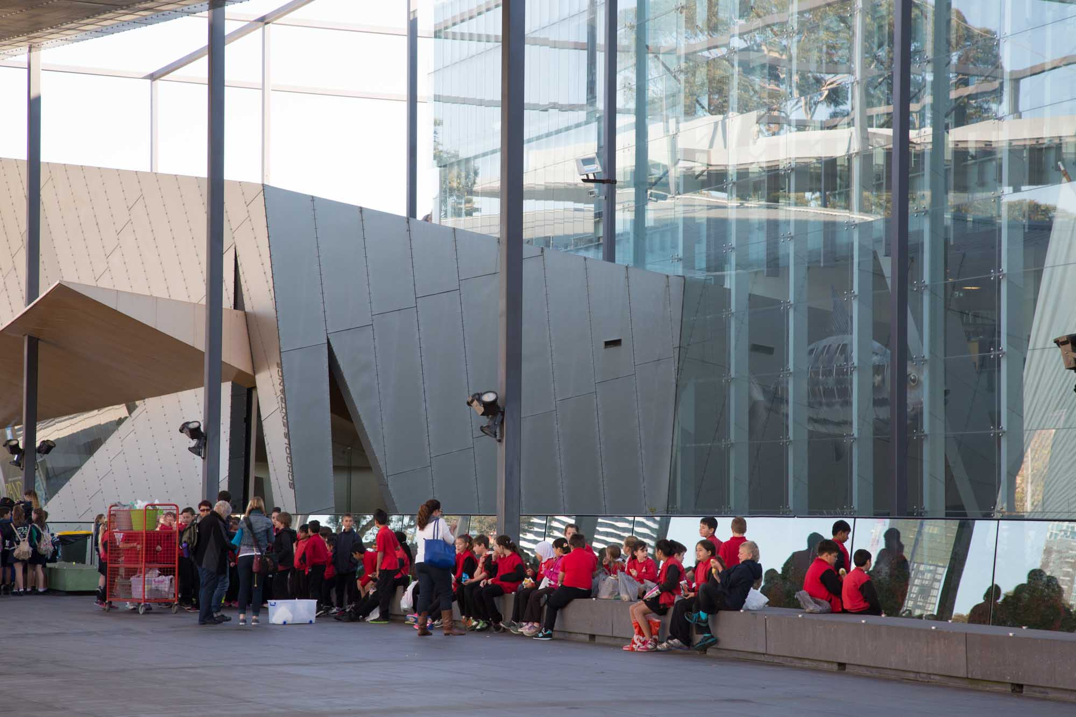

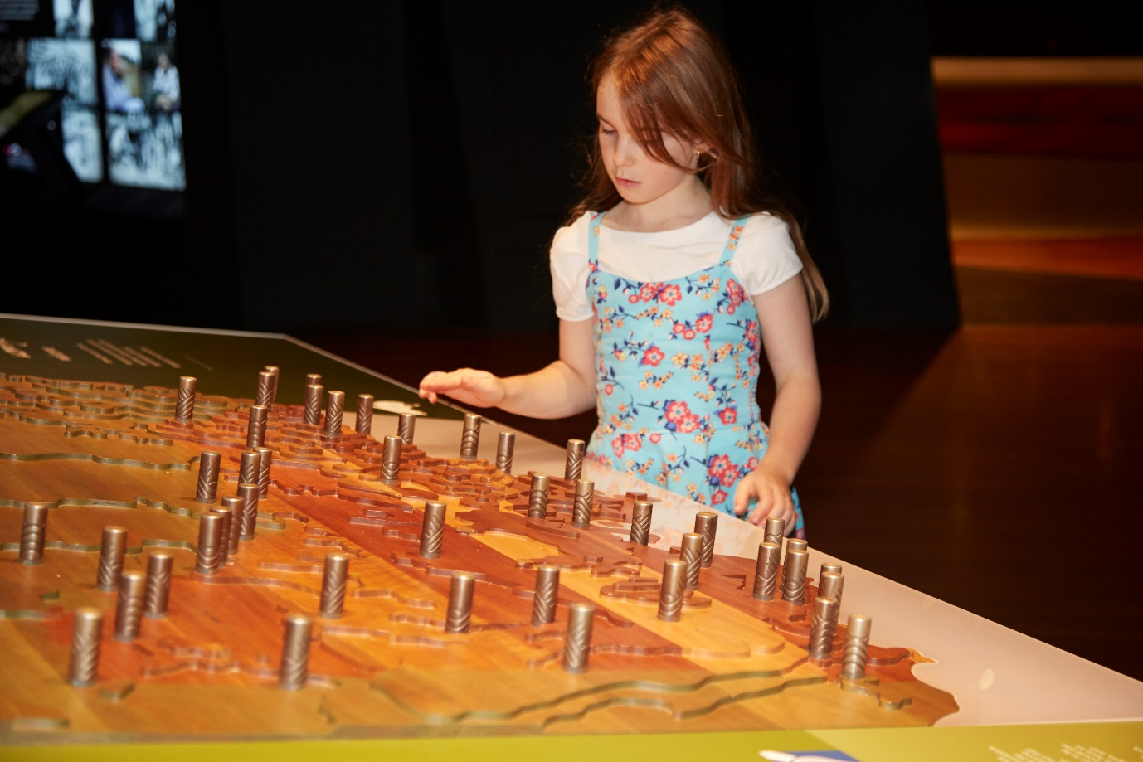
What is Melbourne Museum?
Melbourne Museum has thousands of big and small things on display. I might see dinosaurs, fossils, plants, animals, rocks and minerals, and things that people have made like canoes, computers and cars. These things, as well as images and sounds, explain our history and the natural world. I can look, listen and learn at the museum.

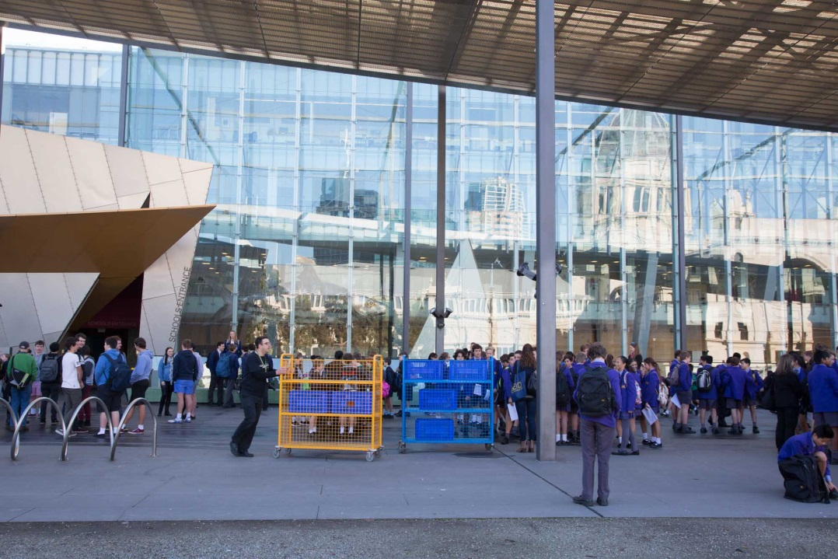
Arriving at the museum
I will walk with my class across a concrete area to get to the door into the museum. My teacher will go inside to get the program for the day. The class may have to wait outside before we go in. That’s okay because I can talk to my friends or look at the buildings or people around me.
My bag will be put on a trolley so that I don’t have to carry it all day. Someone will look after it and I will get my bag back later.
I will stand in line before we enter the museum so the teacher can make sure we are safe. Someone who works at the museum will take us inside.

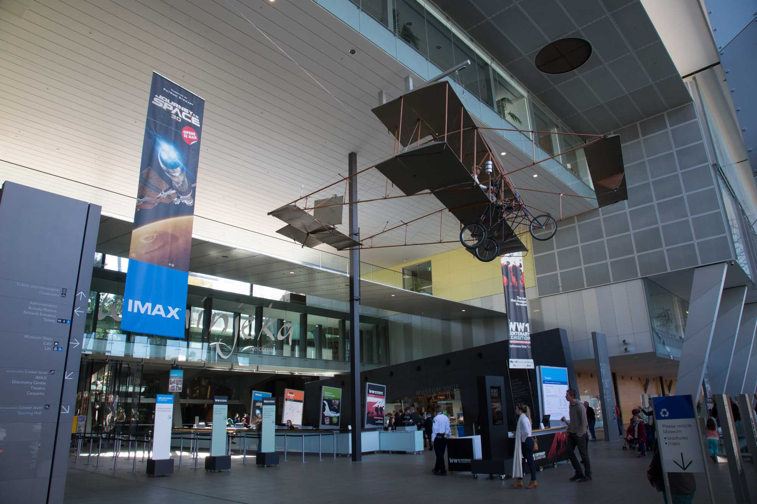
Going into the museum
I will go through big glass doors and see a pretend shark, seals, penguins and little fish in the window.
The next bit is a big space with a very high ceiling. There will be an aeroplane hanging from the ceiling above me. It is held up by a strong cable and it will not fall on me.
I will go with my teacher and my class past the ticket desk into the big area in front of the Forest Gallery. We will begin our museum visit together from here.
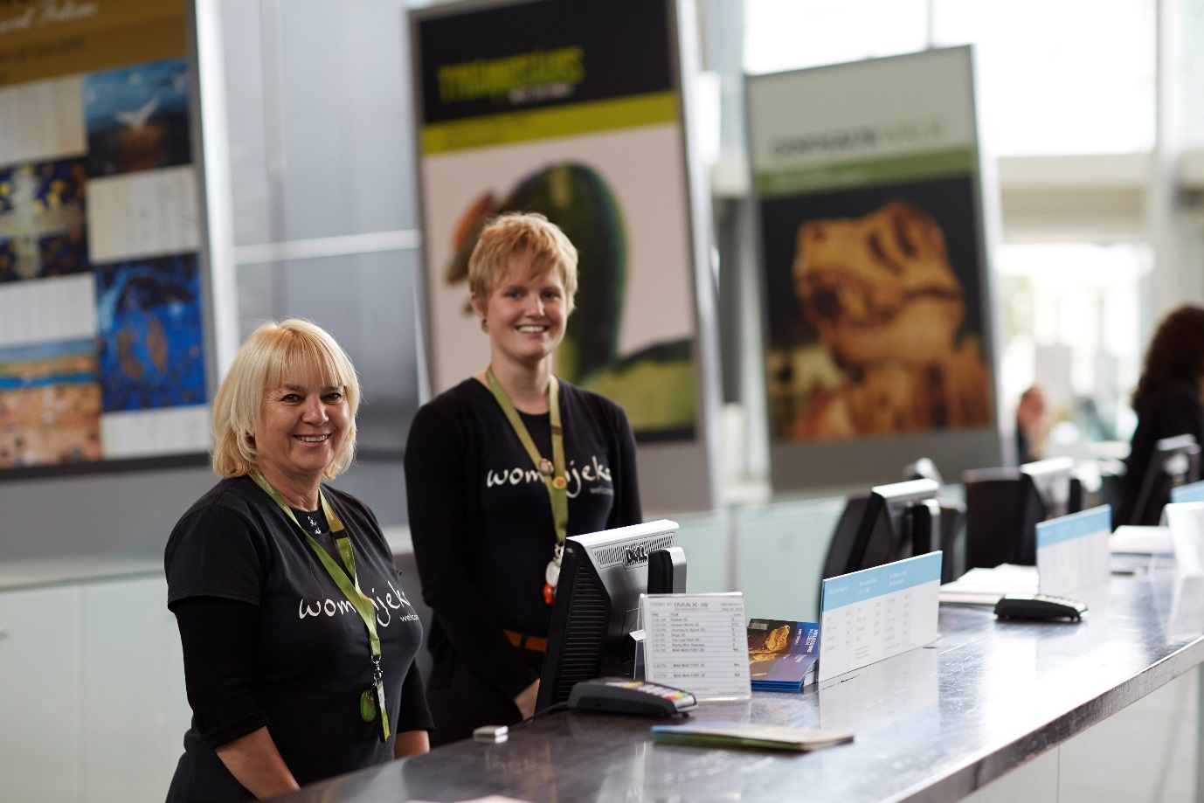
Staff at the museum
Many people visit the museum and many people work there too.
If I get lost, a Customer Service Officer can help me find my class. They wear black t-shirts and have green straps around their necks.

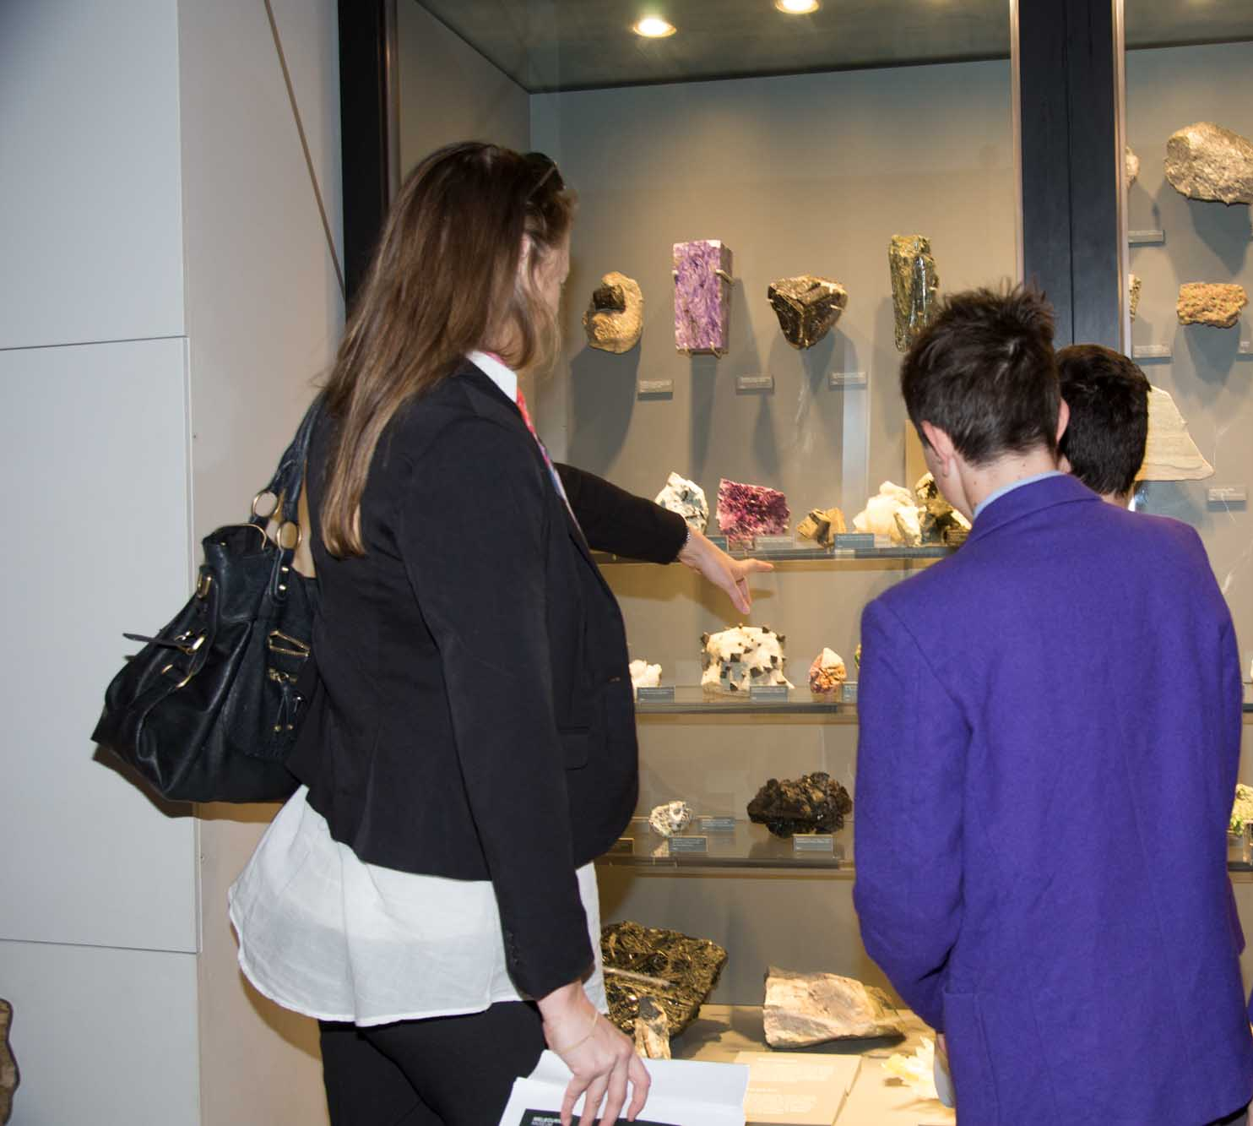
What will I be doing at the museum?
My teacher knows what we are going to do and when.
My teacher will tell the class where we will be going and we will be moving around the museum as a group. I might visit many areas of the museum or just a few. I will follow my teacher and I will stay with the group.
My teacher will tell me when I can eat and when I can get my food from my bag.
After we have done all the things that our teacher has planned, we will go to collect our bags. Then we'll all go back to school.

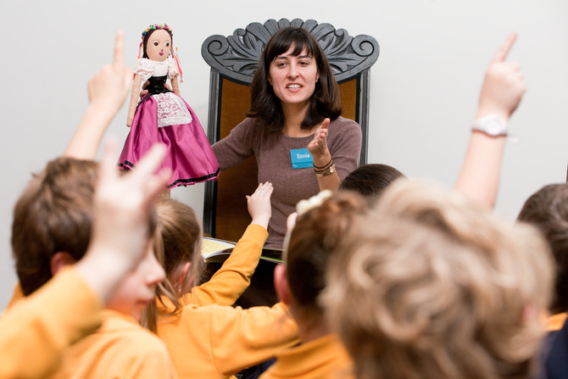
Special booked programs
My class might go into special area so someone from the museum can talk to us.
I will sit as still as I can, listen to the person talking and put my hand up if I have an answer to a question. I will not talk unless I am asked to give an answer. I will not interrupt the person speaking.
Our class might have the chance to hold special things during our visit. If someone else from my class is holding something I will just look at it. If I do get to hold something I will be very careful.
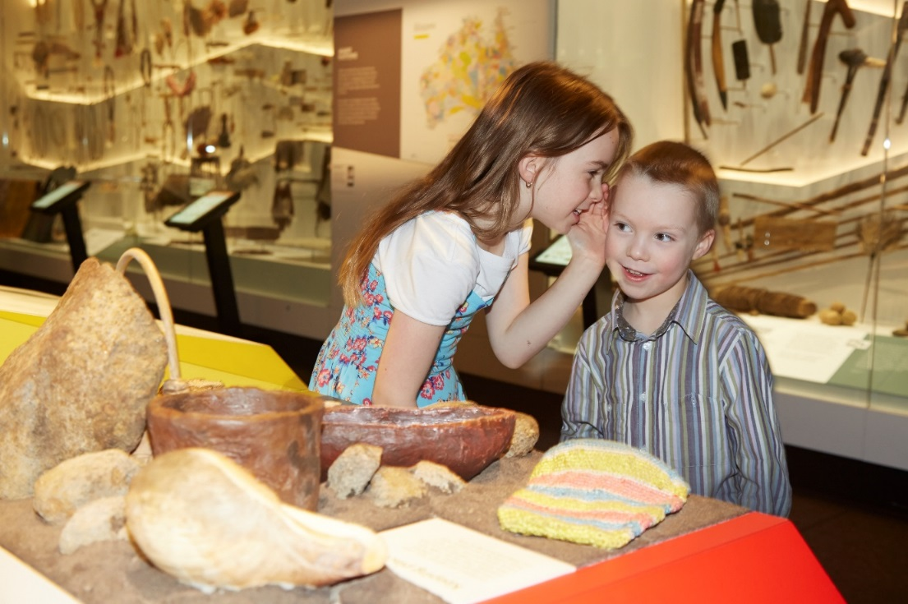
Some important things to remember at the museum
When I visit Melbourne Museum I must remember to:
- Follow the adult who is leading my group
- Stay close to my group
- Walk and not run
- Speak with my quiet voice, even though it may be noisy
- Take turns with other children
- Wait patiently when I have to line up
- Only touch things I am told that I am allowed to
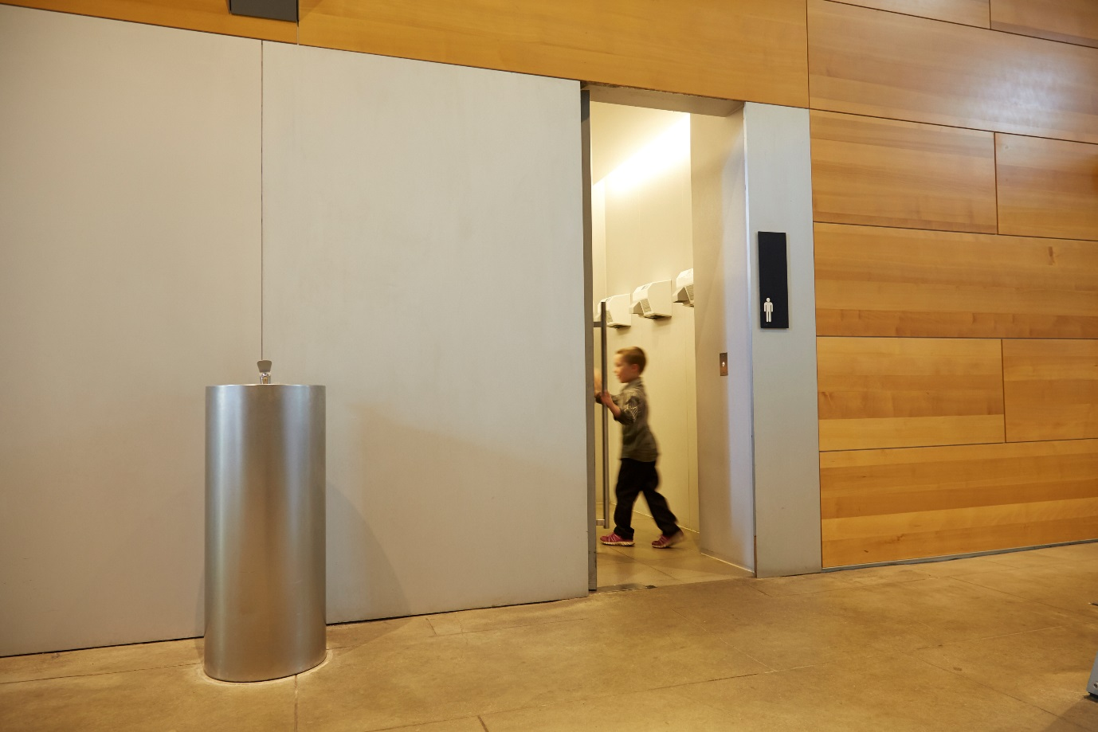
Toilets at the museum
I will tell my teacher if I need to go to the toilet and they will take me to a bathroom. There are lots of bathrooms in the museum. There might be other people in the bathroom too. When I am finished using the toilet, I will wash my hands.

Food and eating at the museum
When it is time to eat, I will go with my class to eat outside or to the playground. If it is raining the class might sit on the floor of the museum to eat. I will not eat inside the museum unless my teacher tells me I can.

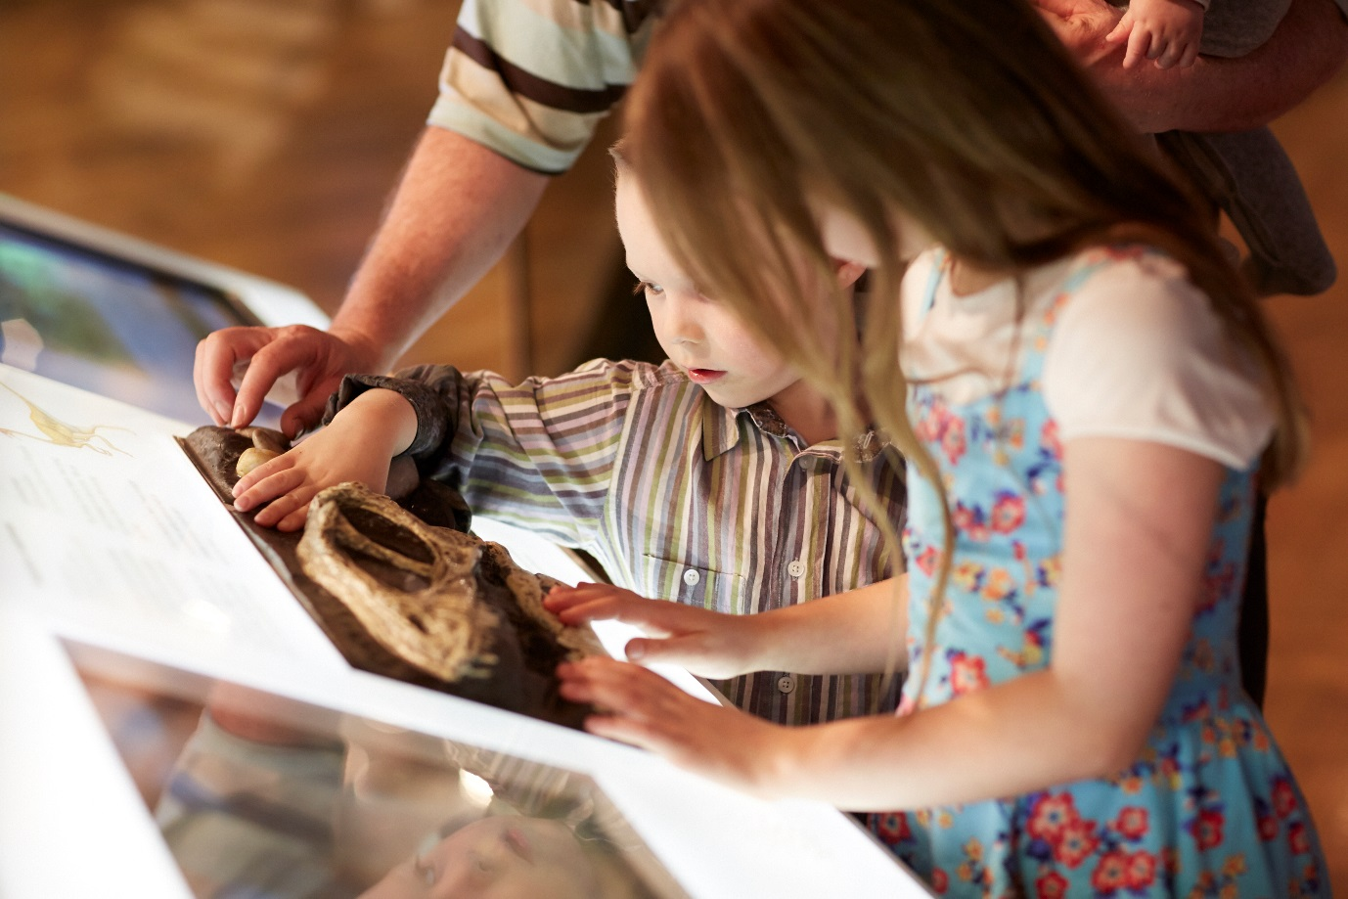
What can I touch?
At the museum there will be lots of interesting things. I am allowed to touch some of these things. There are other things that I cannot touch. I will just look at these things. I will be told which ones I can touch and which ones to just look at. If I am not sure whether I can touch something I will ask an adult.

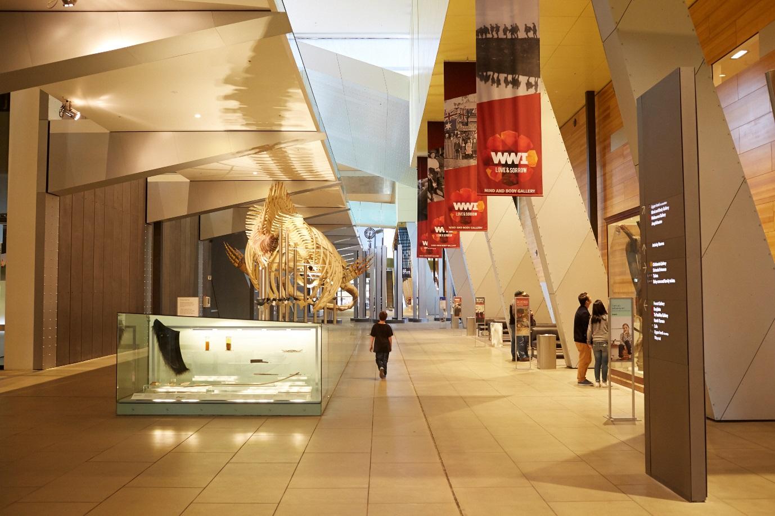
Big spaces
The museum is a special building and inside it looks and feels different to home or school. Some rooms at the museum are big. Some rooms at the museum are small. Some rooms at the museum might be dark or bright. If I don’t like being in a room and feel uncomfortable I will tell an adult.

