My visit to Melbourne Museum
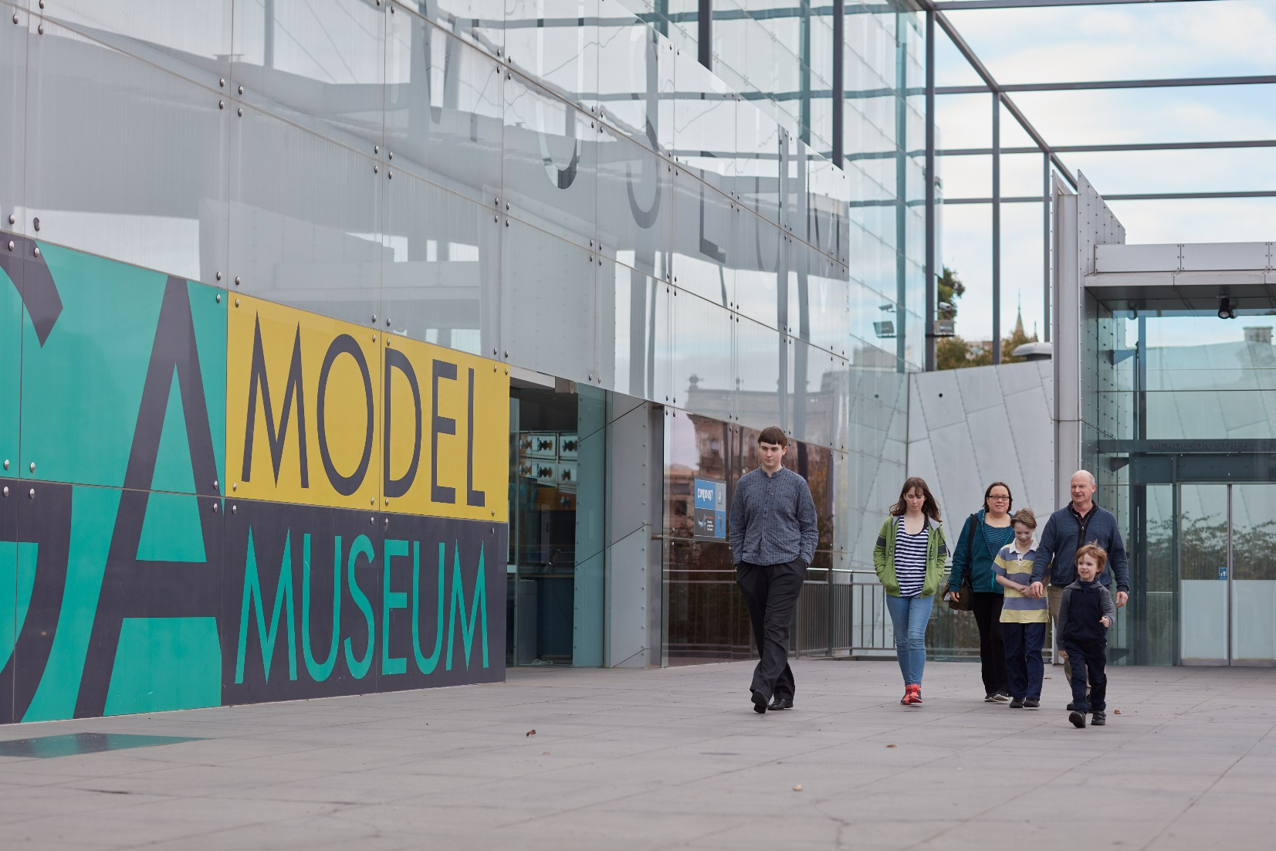

I am going to visit Melbourne Museum.
Because of the COVID-19 virus, there will be some changes at the museum.
I can help myself to stay healthy and everyone else too by following the guidelines in this story.

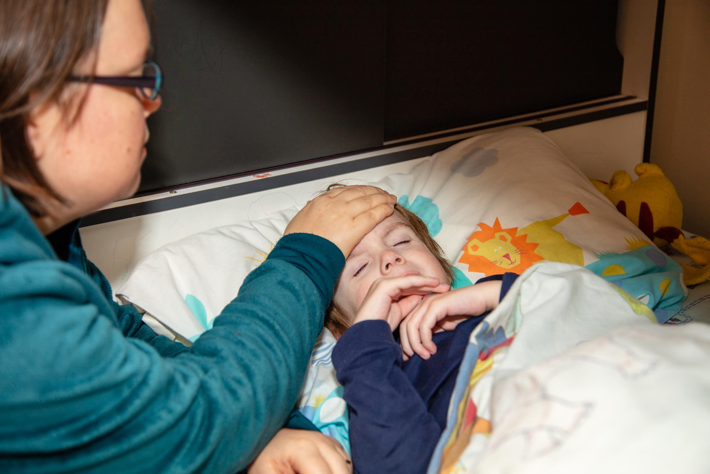

I will stay at home if I feel unwell.

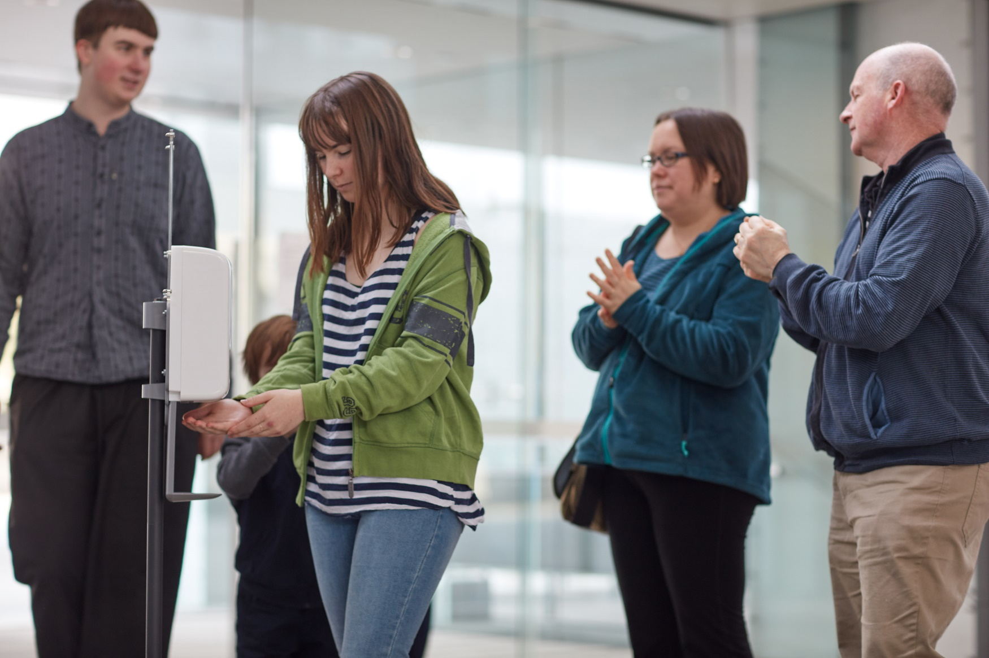

I will use the hand sanitiser when I arrive at the museum and when I leave.
There are hand sanitisers all around the museum for me to use.

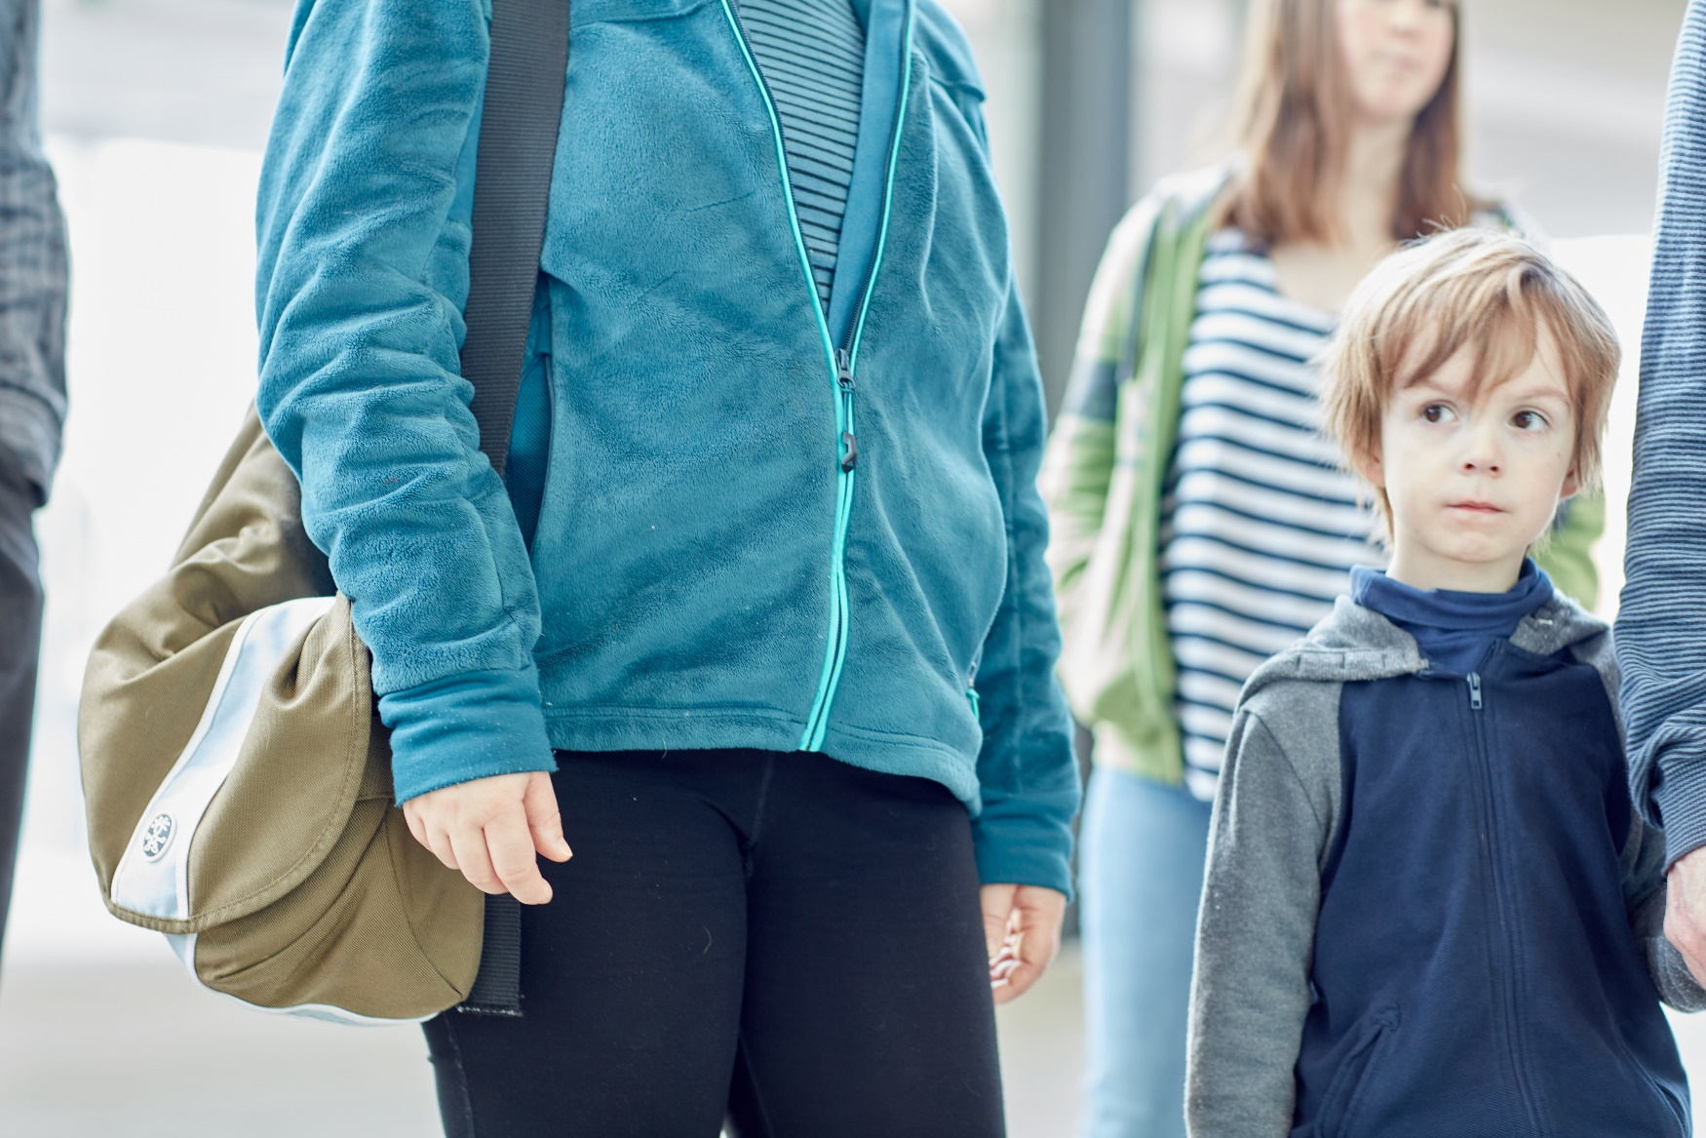

I will carry my own belongings as museum staff will not be in the cloakroom.

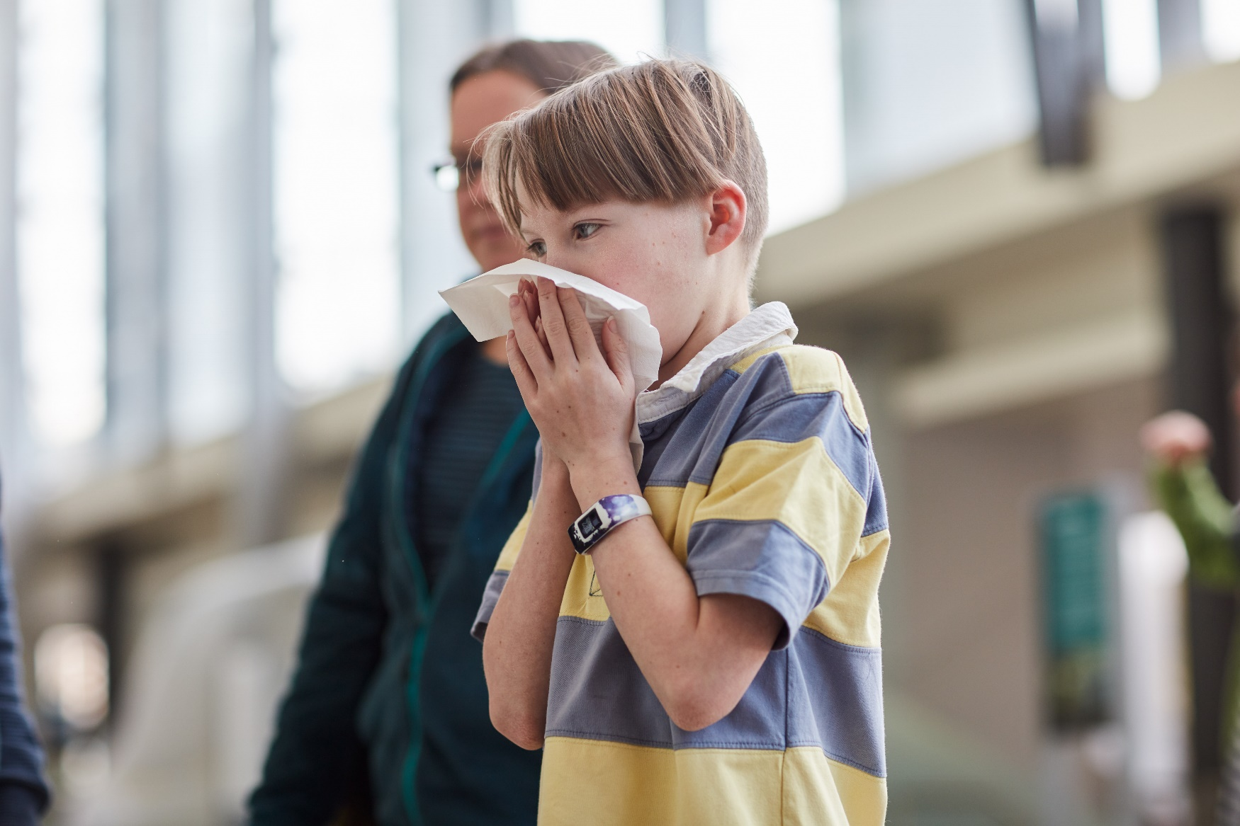

If I need to cough or sneeze, I will use a tissue and put it in the bin.
If I do not have a tissue, I can cough or sneeze into my elbow.

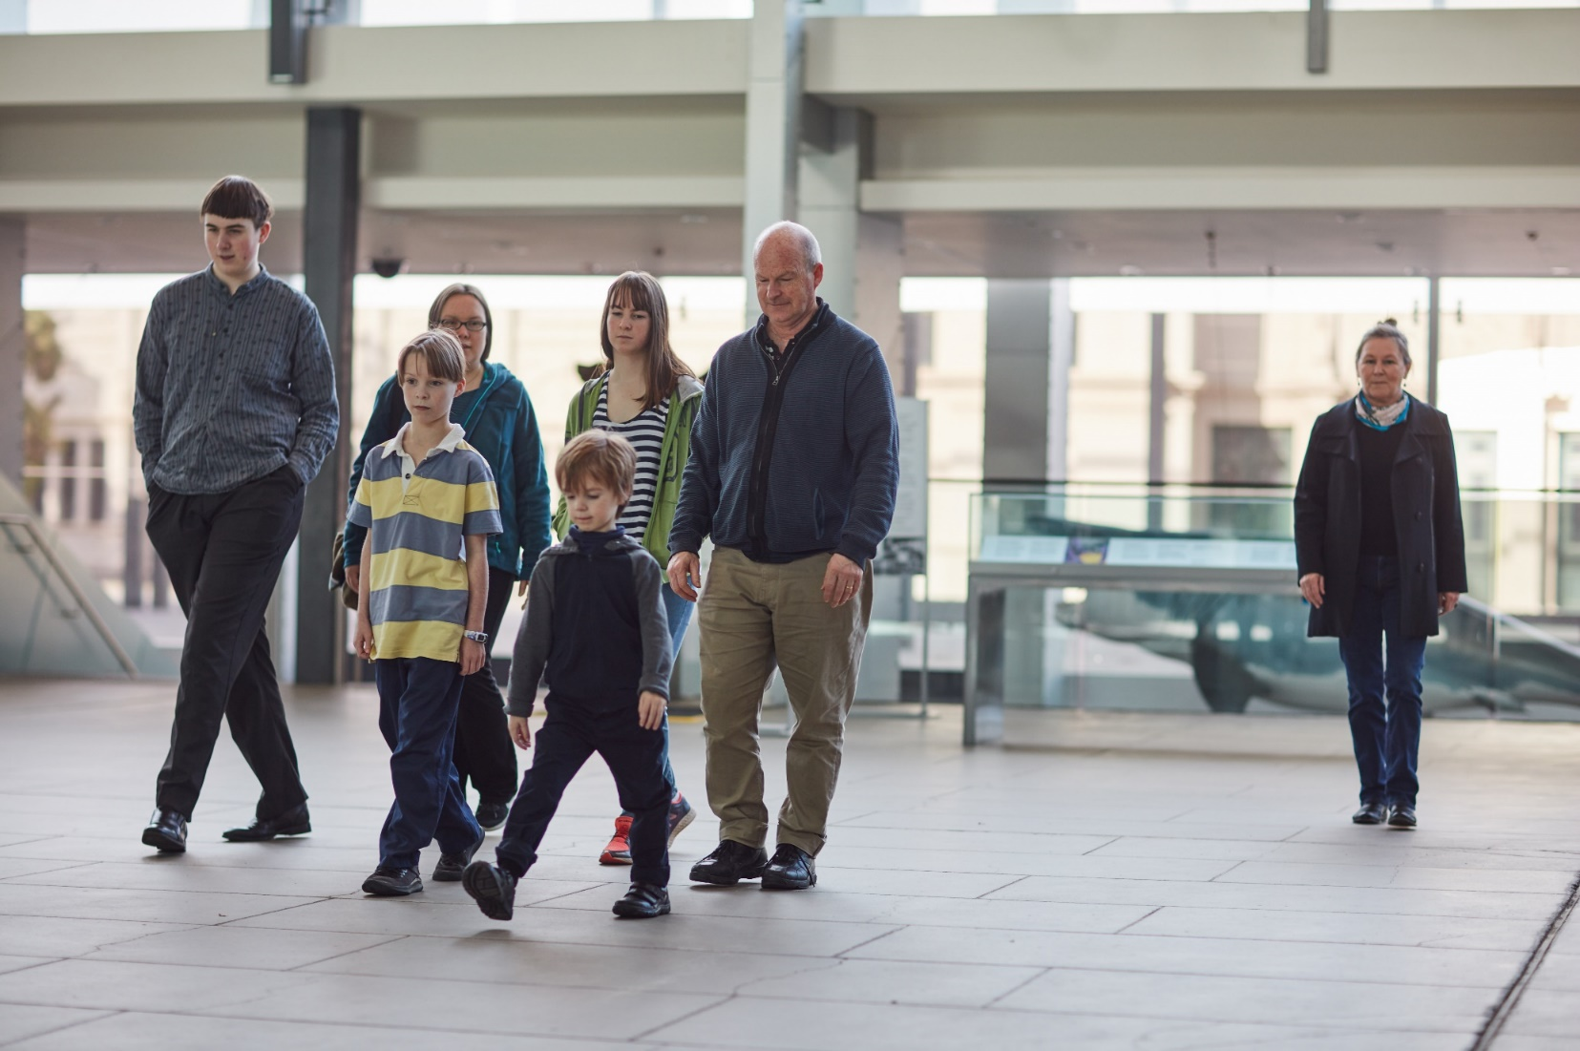

I will stay as far away as I can from people who are not in my group. The safe distance is 1.5 metres.

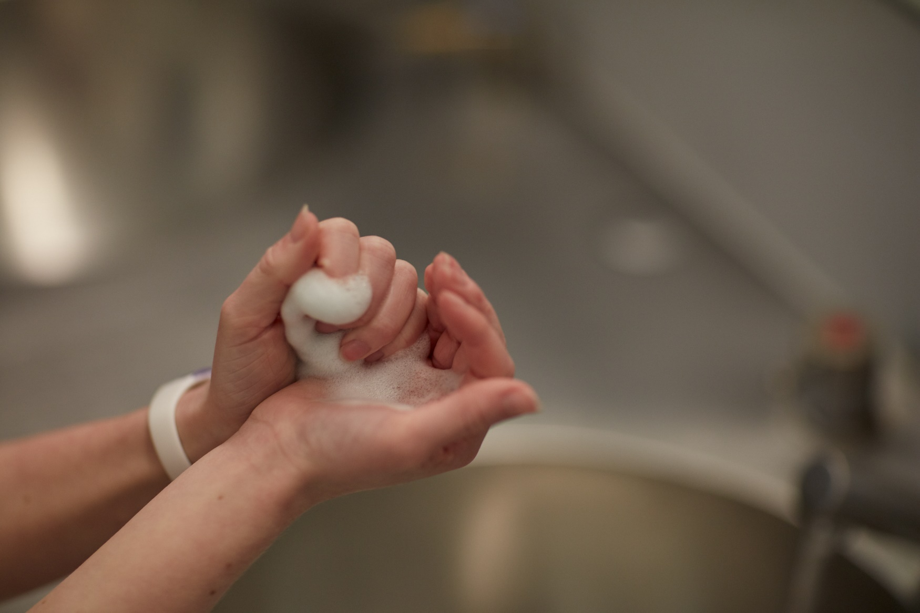

When I go to the toilet, or before and after eating, I will wash my hands with soap and water for at least 20 seconds.
There will be hand dryers in the bathrooms, but I do not have to use them.

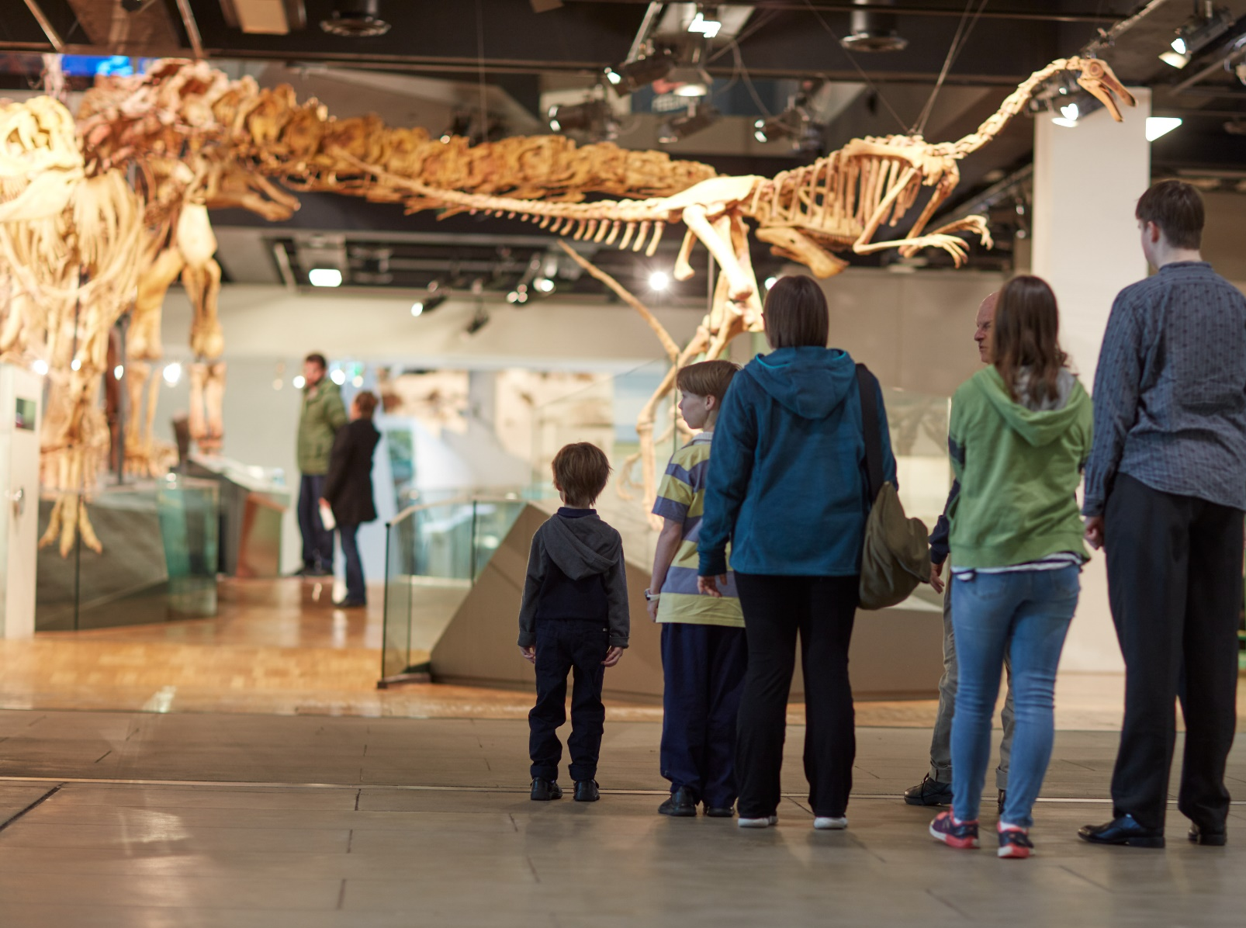

I might have to wait to go into a gallery or exhibition at the museum, and that is okay.
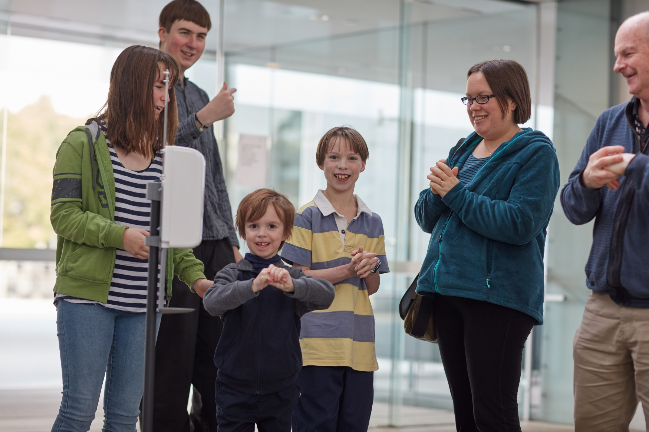

I am going to enjoy my visit to the museum.

Notes for parents and carers

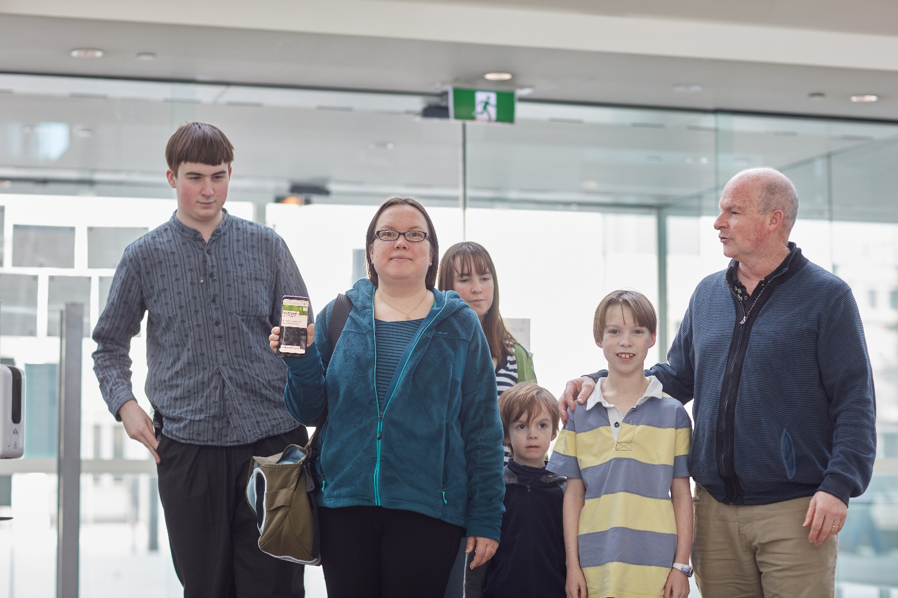

- You can book your tickets before you arrive at the museum.
- Stories which describe the museum for both young and older children can be read in conjunction with this story.
- We hope you enjoy your visit.

