**The Museum visit to our kindergarten**

My kindergarten teacher has arranged a visit from Melbourne Museum.

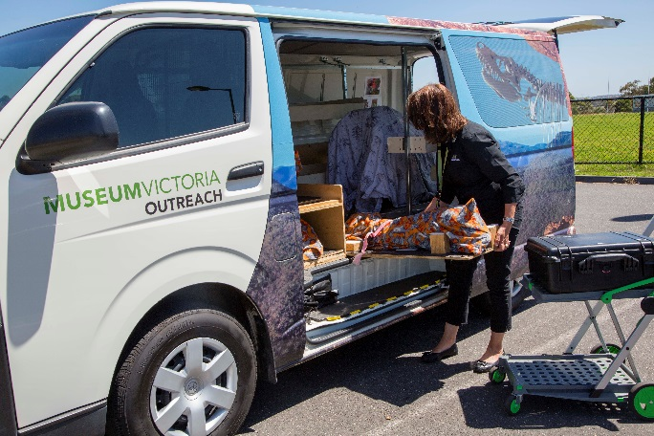

A visitor from the museum will arrive in a big van and bring objects inside to show my kindergarten group.

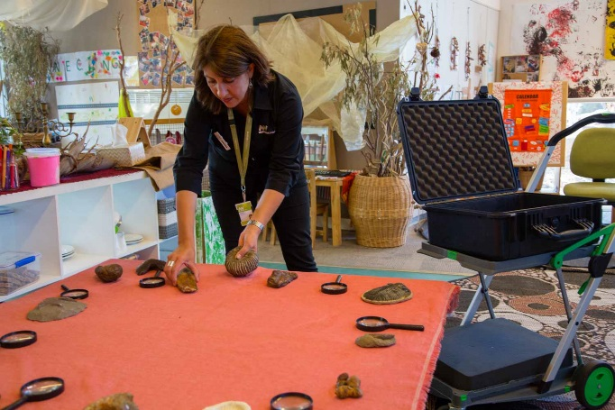

The museum visitor may move the furniture around in my kinder room to make space for the museum objects.

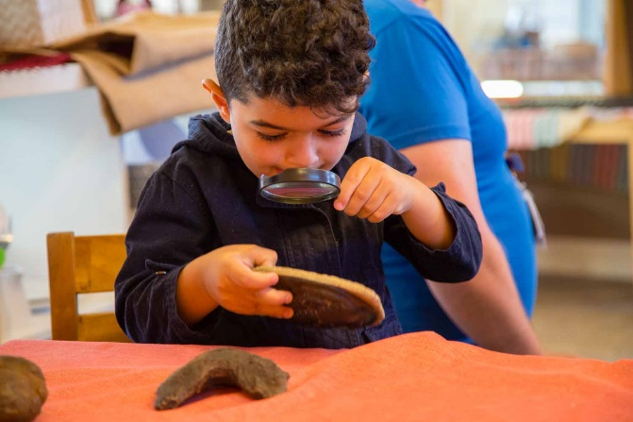

Dinosaurs and Fossils Program

I may get to see dinosaurs and fossils.

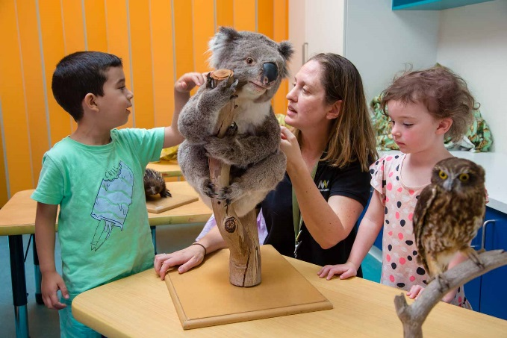

Australian Animals Program

I may get to see Australian animals.

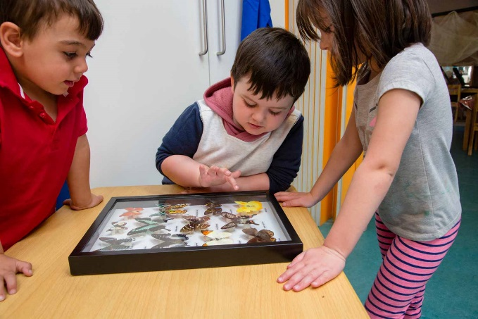

Backyard Bugs Program

I may get to see bugs.

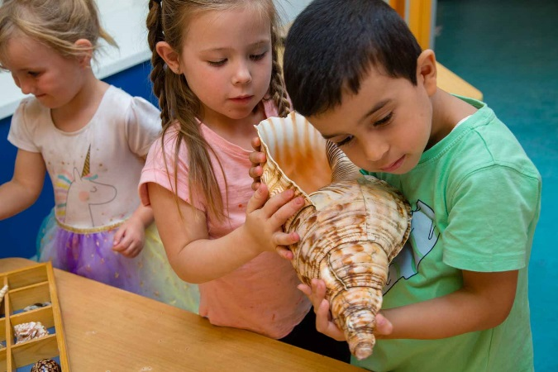

Ocean Wonders Program

I may get to see something that lives in the ocean.

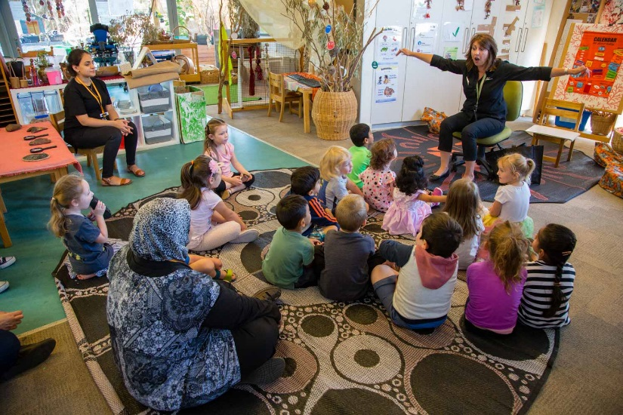

When the museum visitor begins telling us stories about the objects, I will sit on the floor and listen to them.

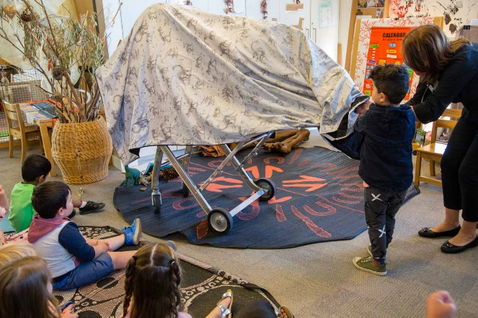

Some museum objects may be covered. The covers will come off as the stories are being told to me.

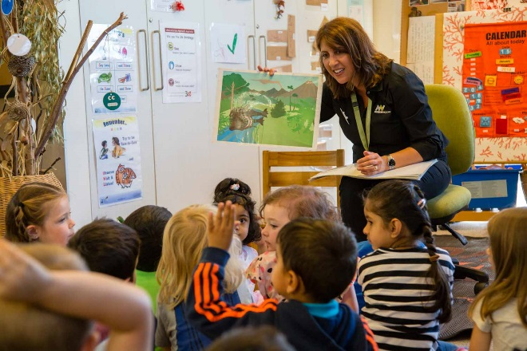

I may want to ask questions about or touch the objects I can see, but I will wait until the museum person invites me. I will take turns to ask questions.

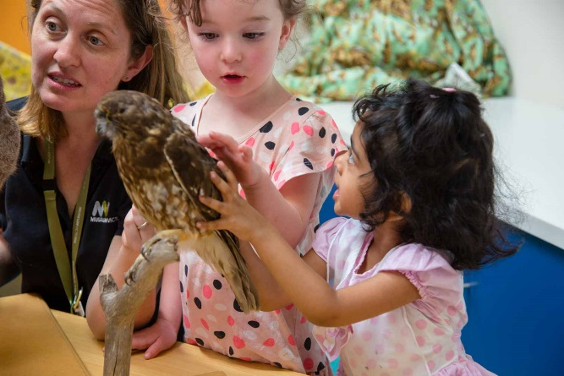

The objects are real, but they can’t hurt me.

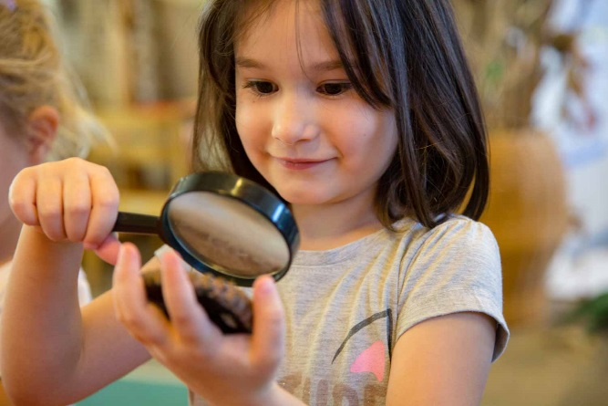

When the museum visitor tells me it is okay, I will be able to touch the objects gently. I do not have to touch anything I don’t want to.

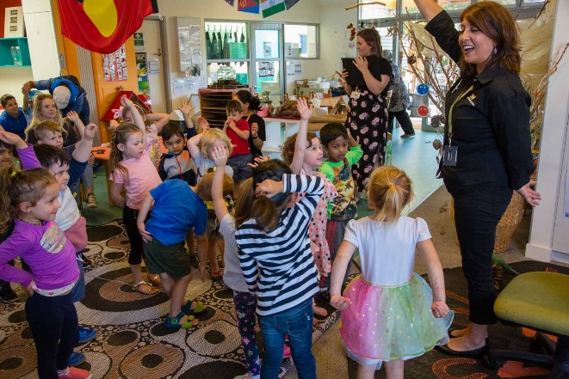

At different times the museum visitor will invite us to move around.

We may touch the objects, dance, play games or make noises. I can join in if I want to.

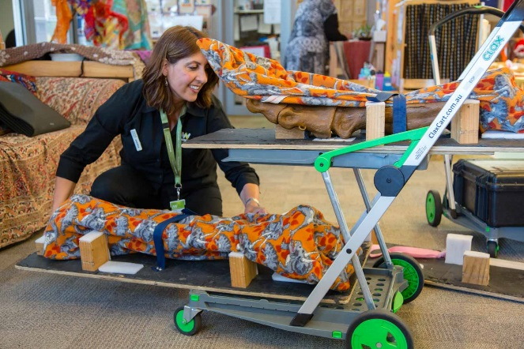

At the end of the visit the museum visitor will pack up the objects and put them back in the van to go back to the museum.

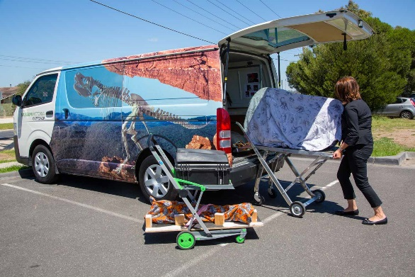

When I get home I can tell my family about the museum visit, the stories I heard and the objects I saw today.