**SOCIAL STORY FOR YOUNGER CHILDREN**

My adventure to Scienceworks

This book belongs to ____________________

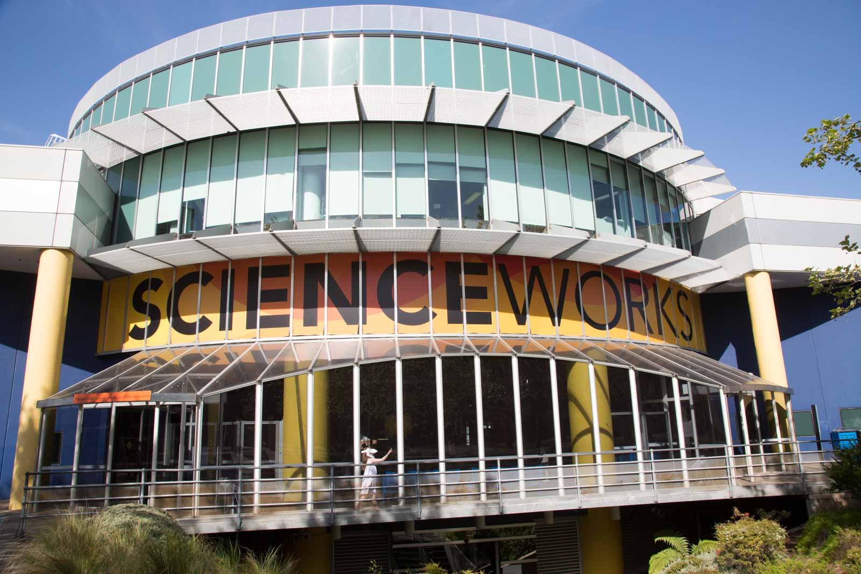

I am going to Scienceworks

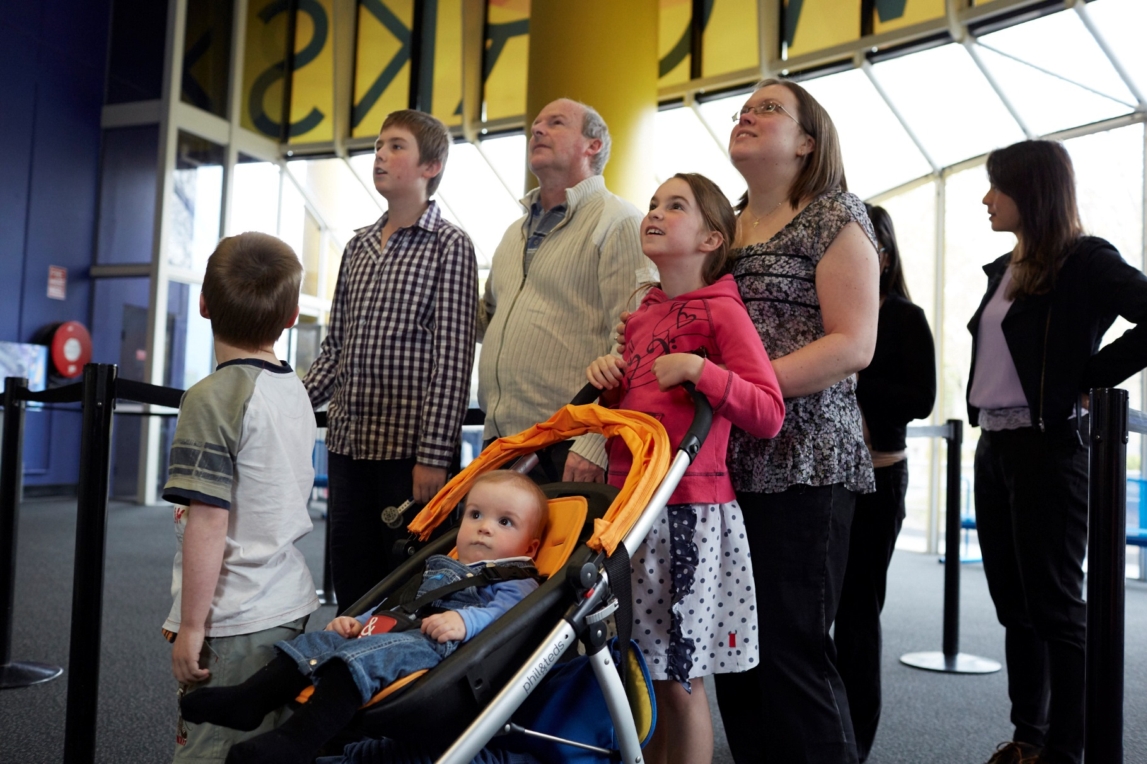

I will have to wait with an adult to buy tickets to the museum. We can decide which shows to see.

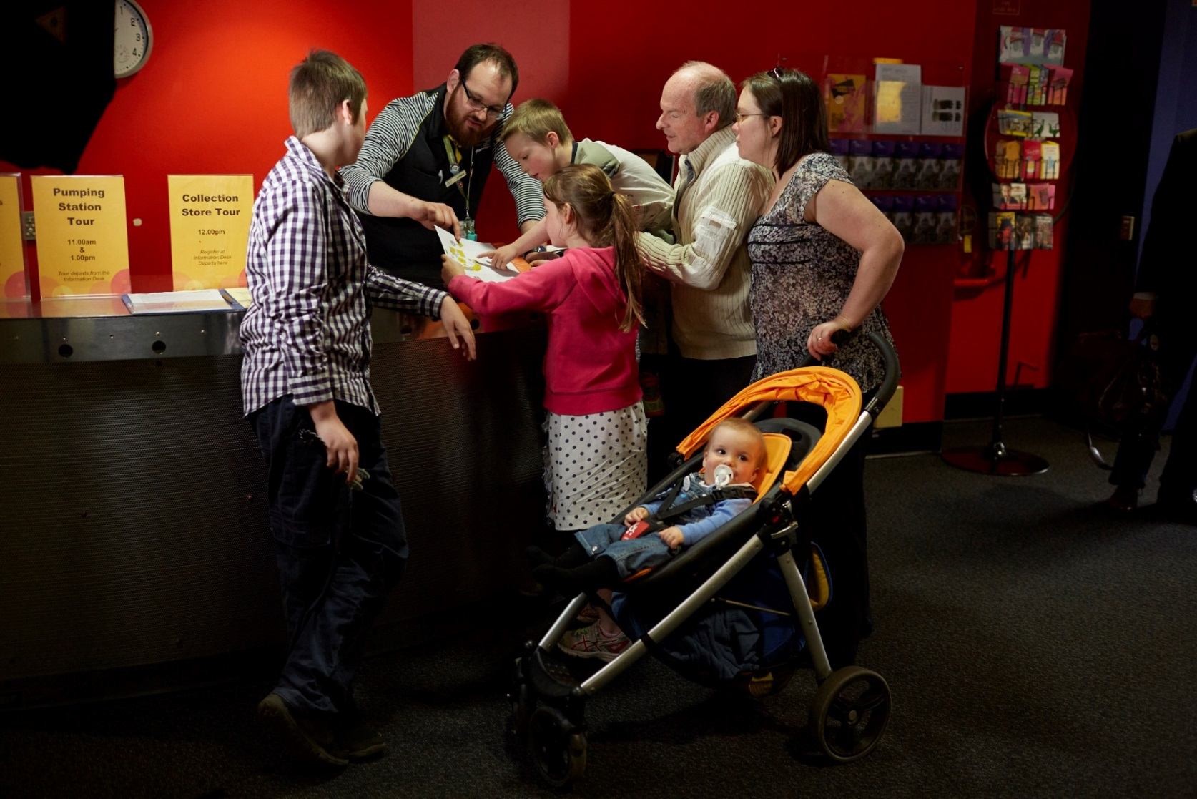

I can get a map at the information desk.

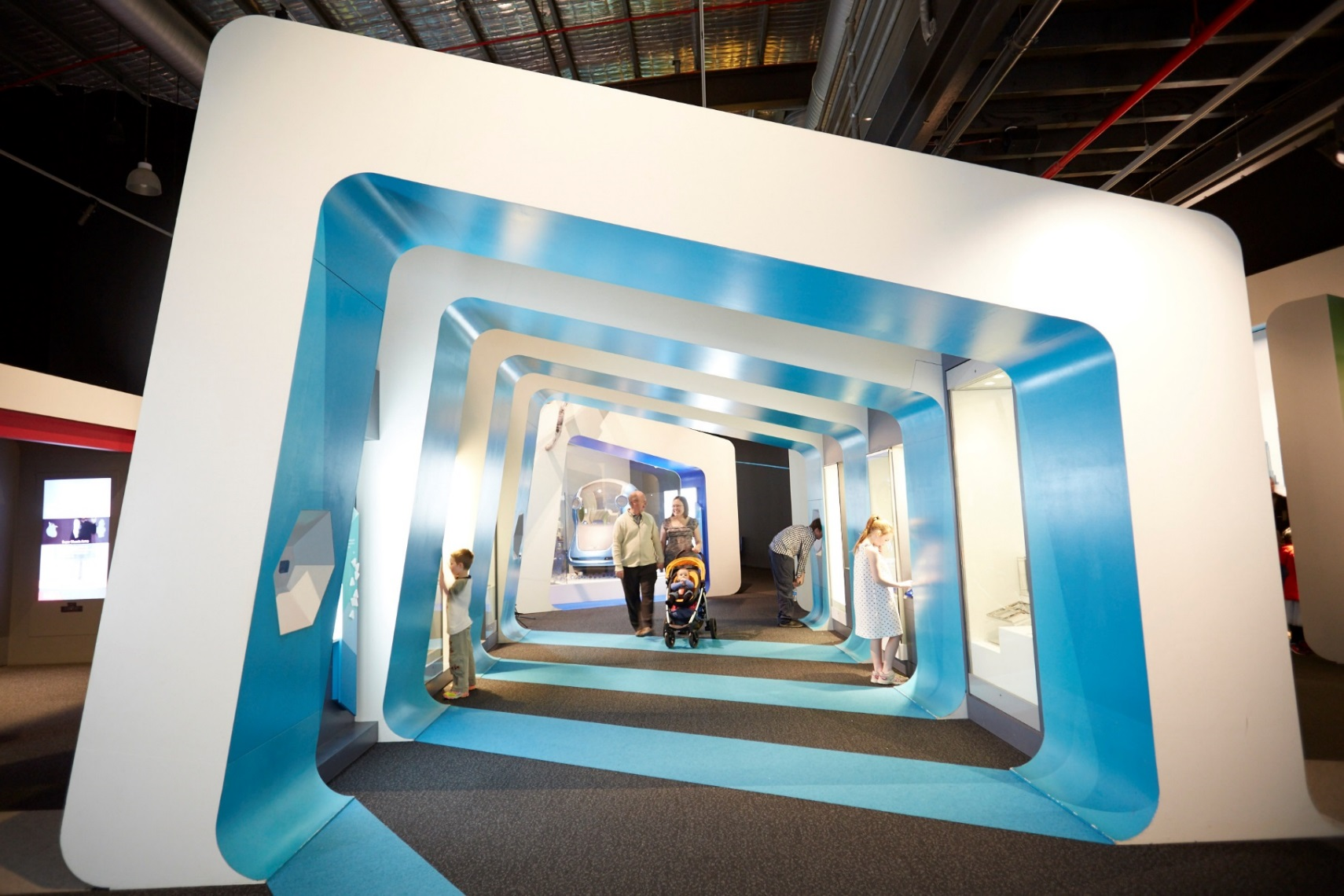

Scienceworks can be very exciting. I will remember to walk and use my quiet voice when I am inside.

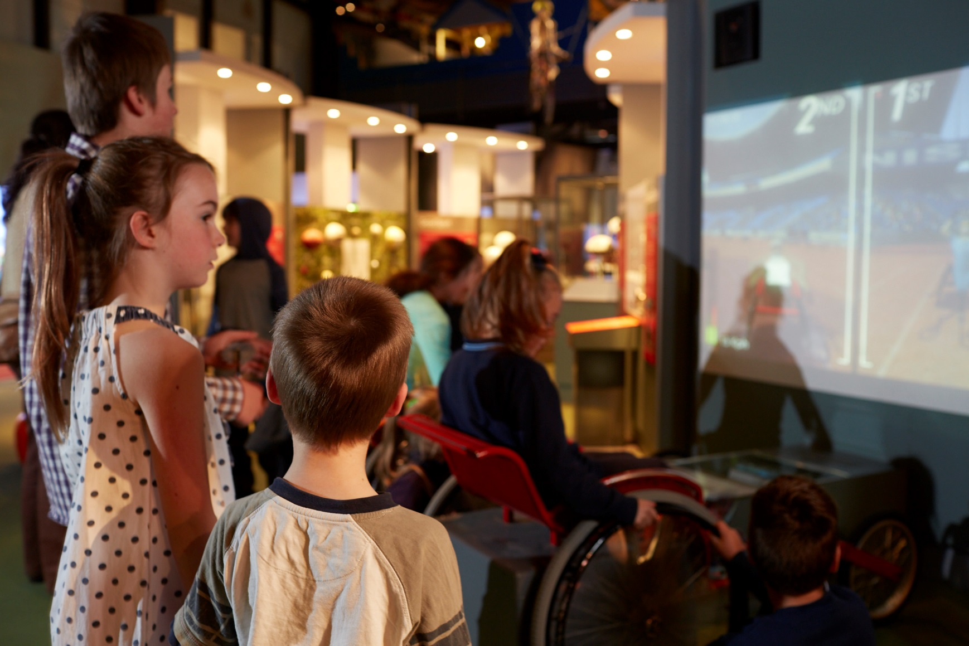

I might wait to see, touch and do things at Scienceworks. I might not have time to see everything.

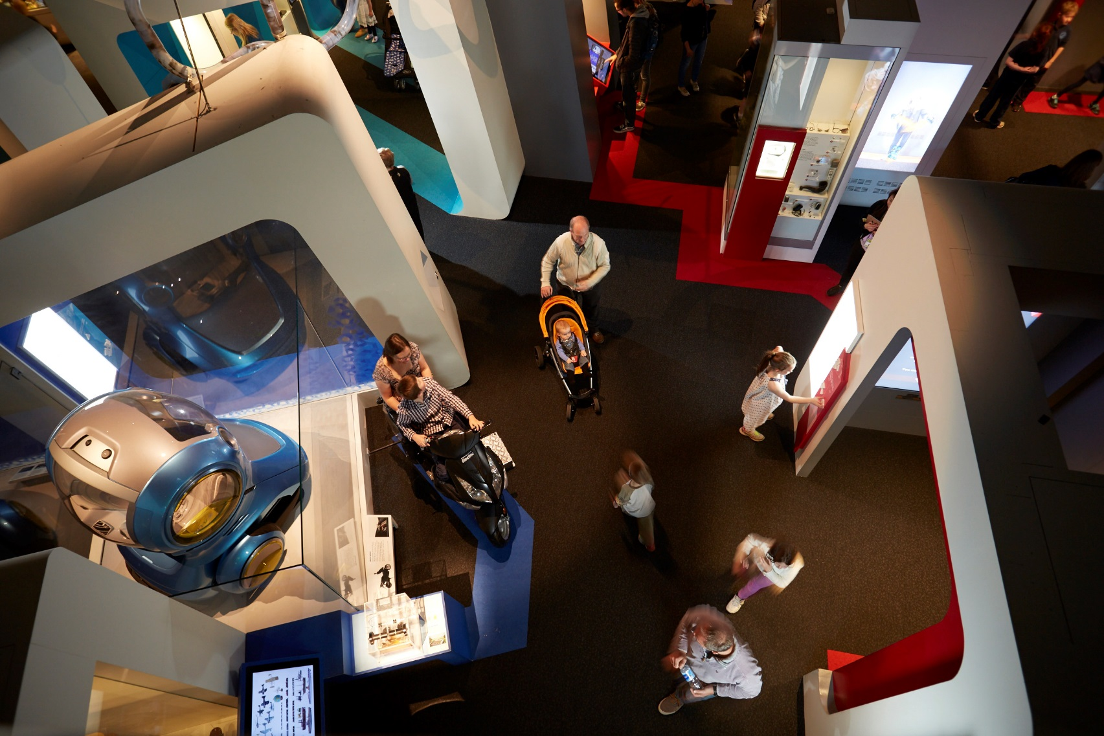

Sometimes it can be noisy and busy at Scienceworks.

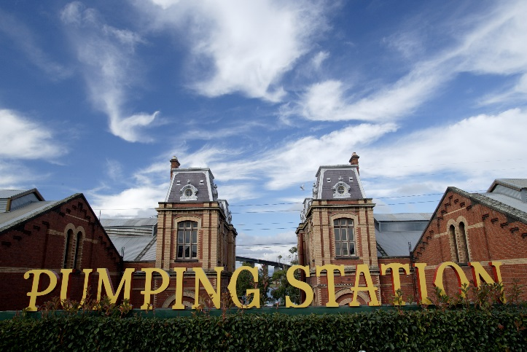

There are quiet places at Scienceworks where I can rest with my family.

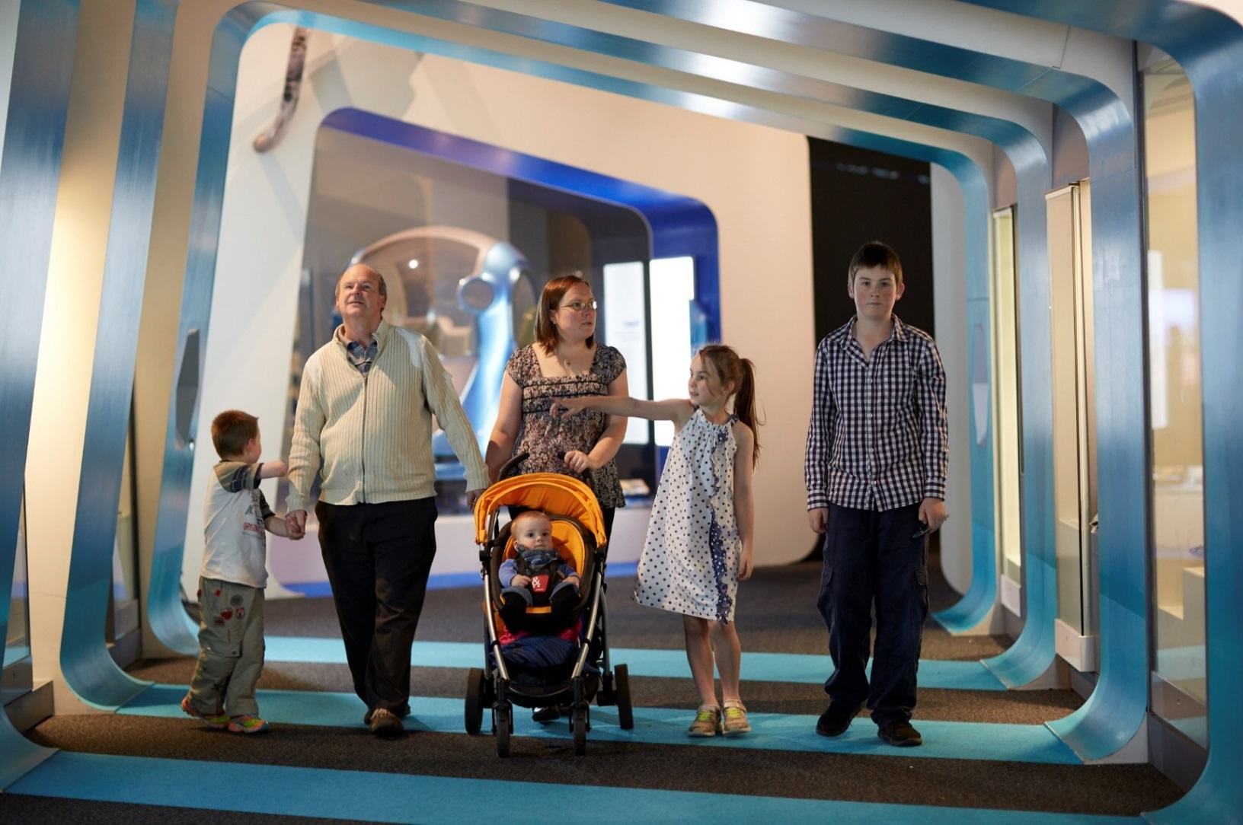

I will stay with my family while I am at Scienceworks

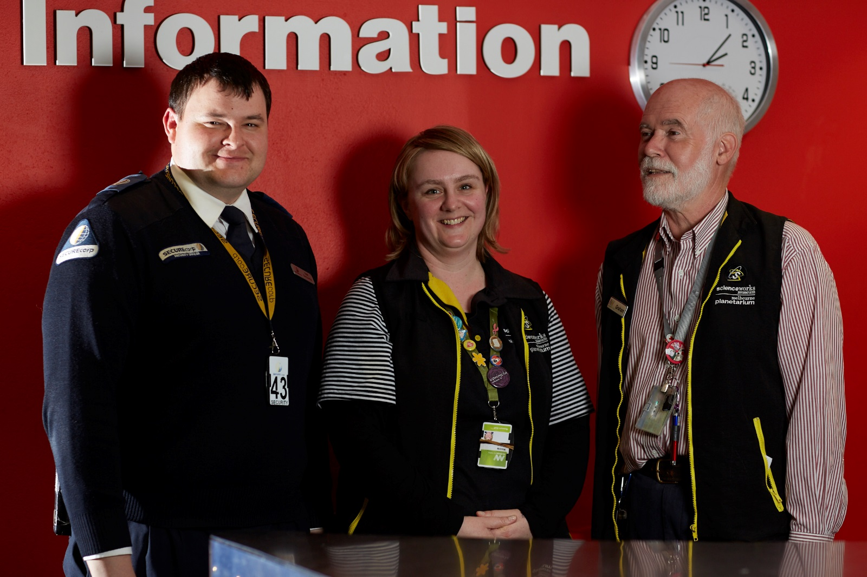

If I get lost, I will ask people who work at Scienceworks for help. They are wearing uniforms and straps around their neck.

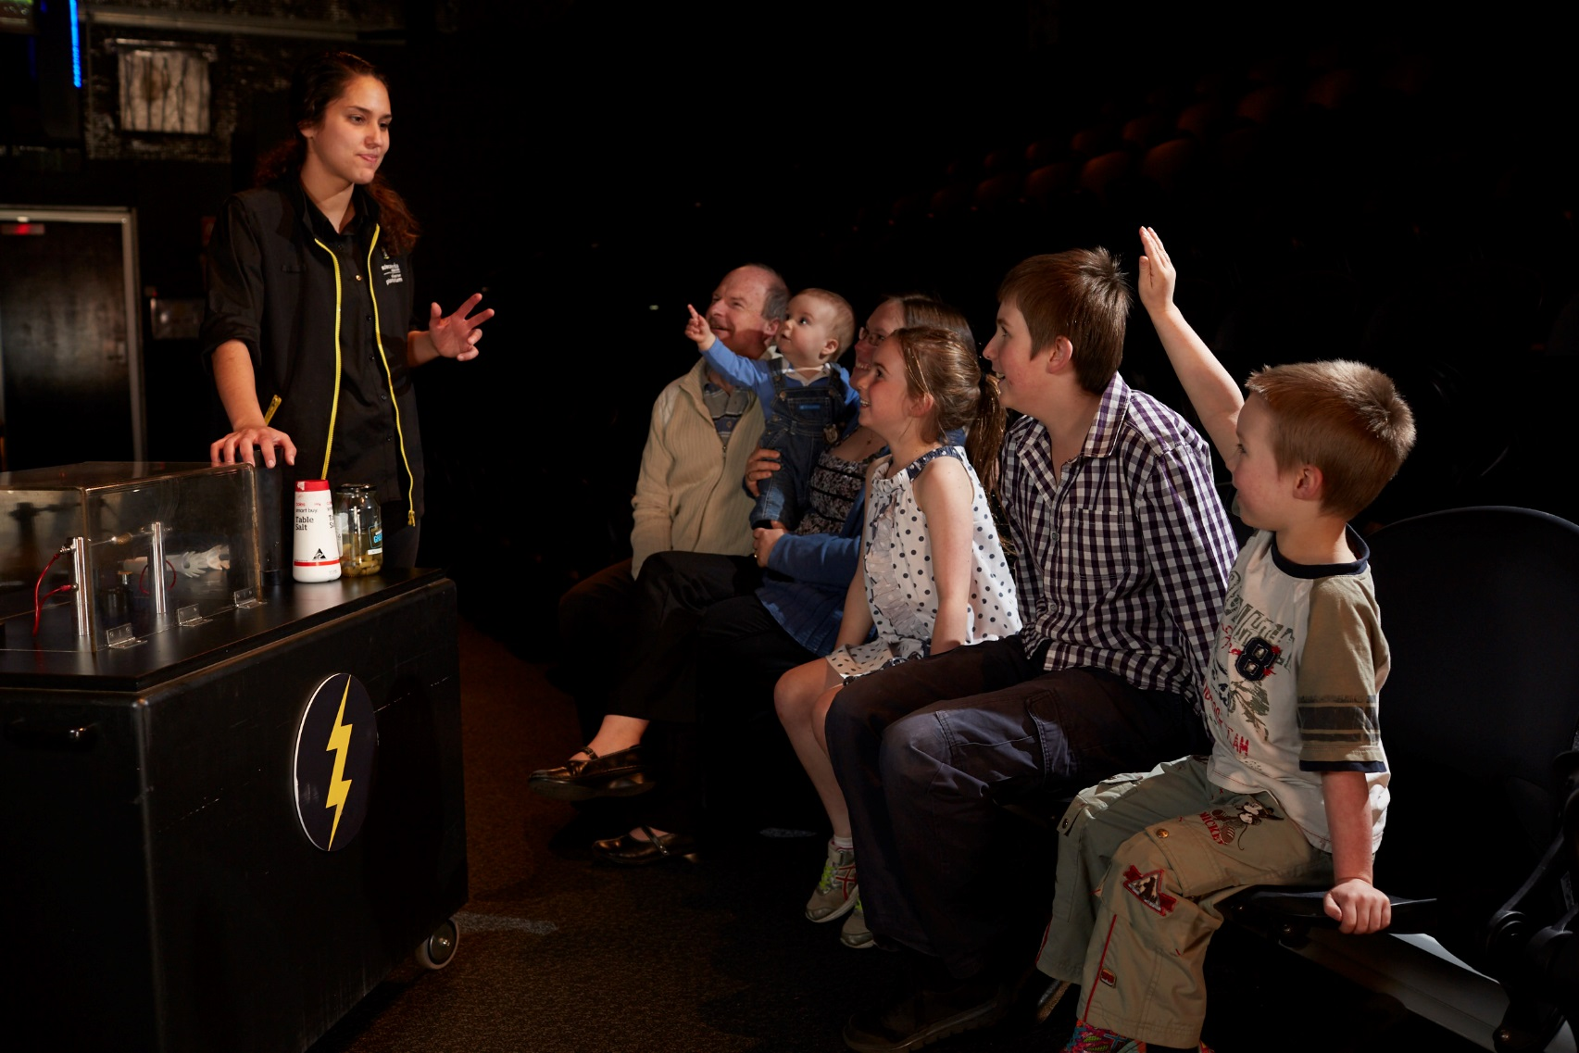

If I see a show at Scienceworks, I will stay in my seat to watch. There may be a lot of excitement and loud noises.

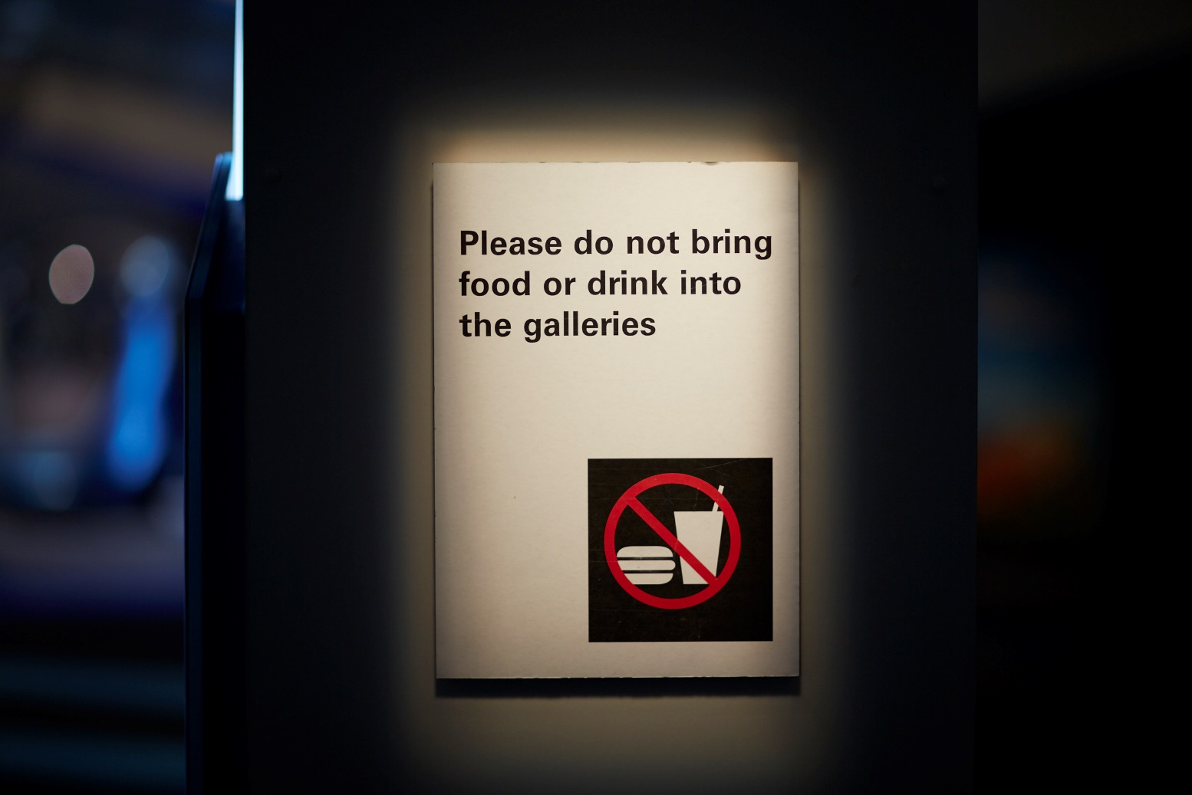

There are special areas I can eat or drink at Scienceworks. I am not allowed to eat in the galleries.

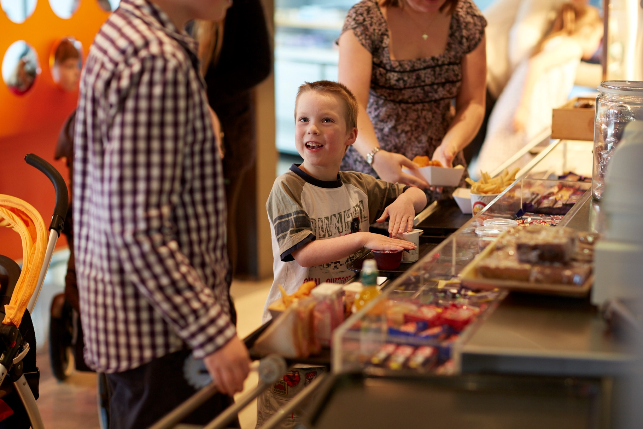

If we buy food from the café I will need to line up. It can sometimes be noisy and busy in the café.

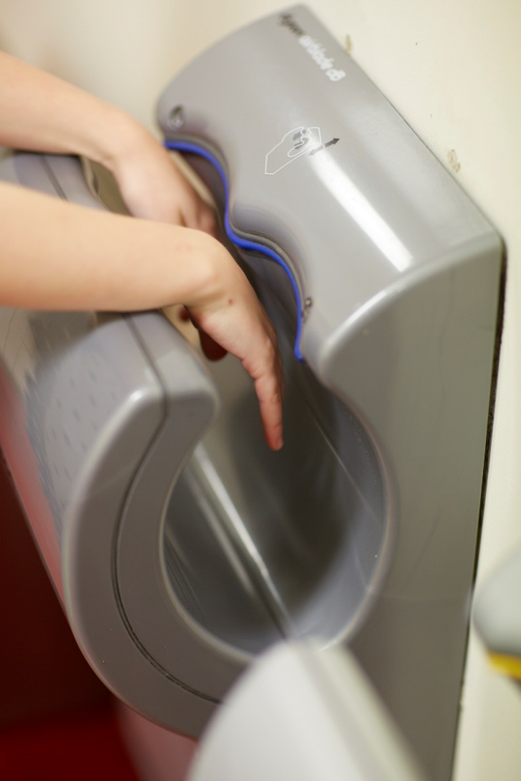

There are some family toilets we can go to together. We can look at a map or ask a staff member. The hand dryers are loud but they dry hands fast.

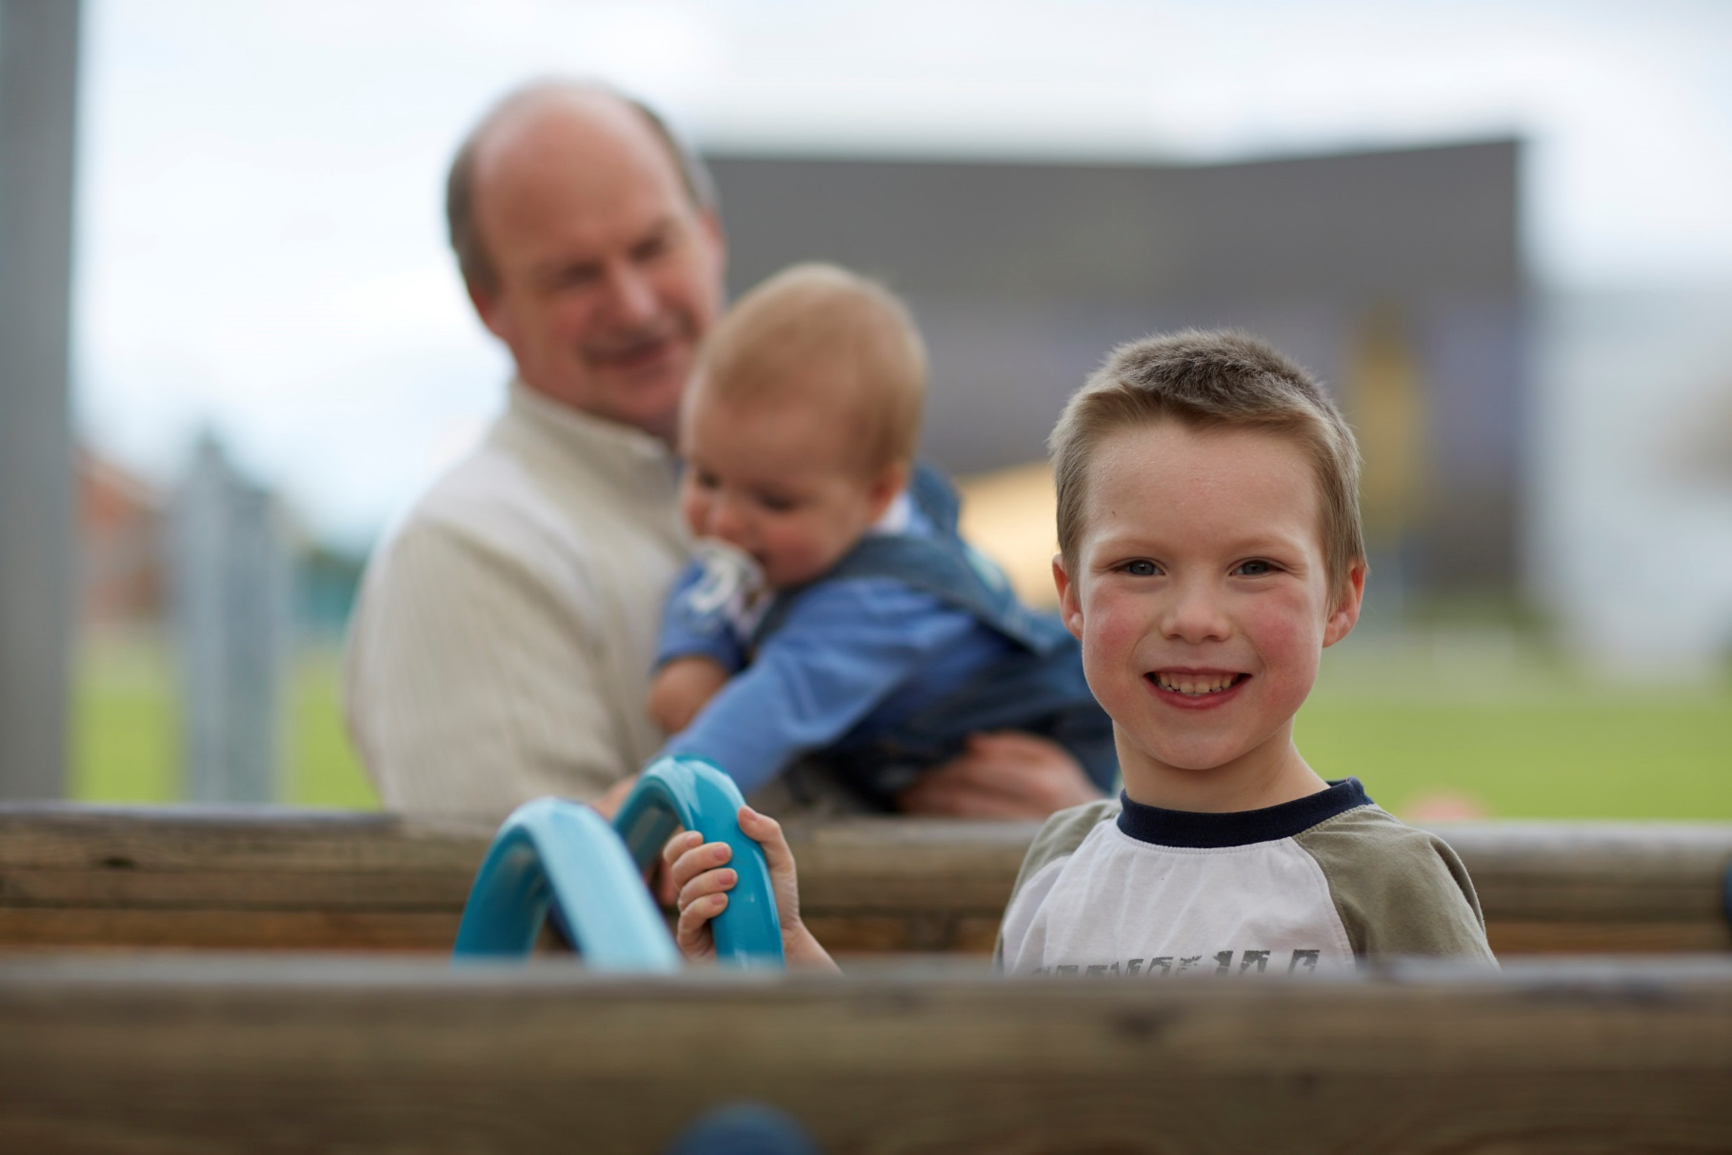

I am going to learn, explore and have fun at Scienceworks.