**Autism Friendly Melbourne Museum**

**SOCIAL STORIES FOR SCHOOL VISITS**

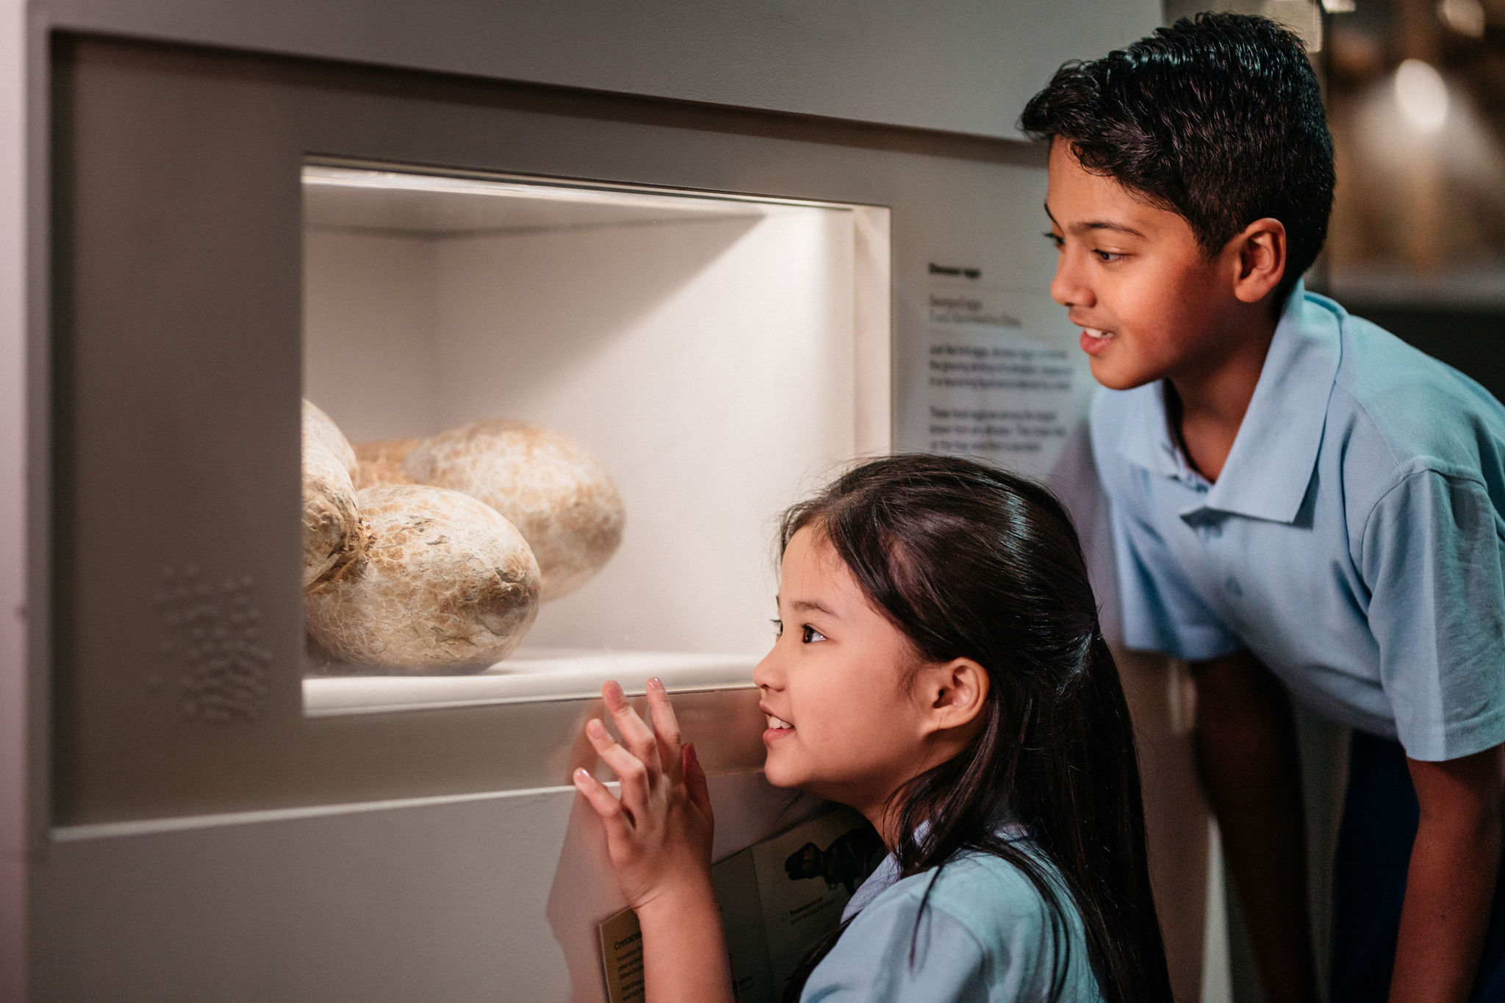

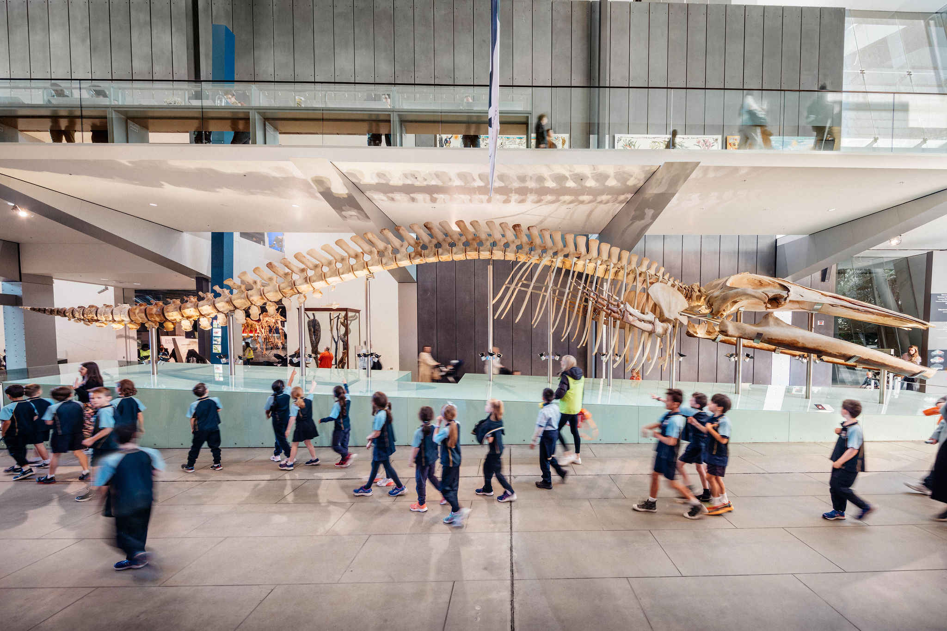

**What is Melbourne Museum?**

Melbourne Museum is a very large museum, with many exhibitions.

I am going on a school excursion to Melbourne Museum with my class.

I might see dinosaurs, plants, animals, rocks, and things that people have made like canoes.

Sometimes museums can be noisy, and I might like to bring my headphones or earmuffs for my visit.

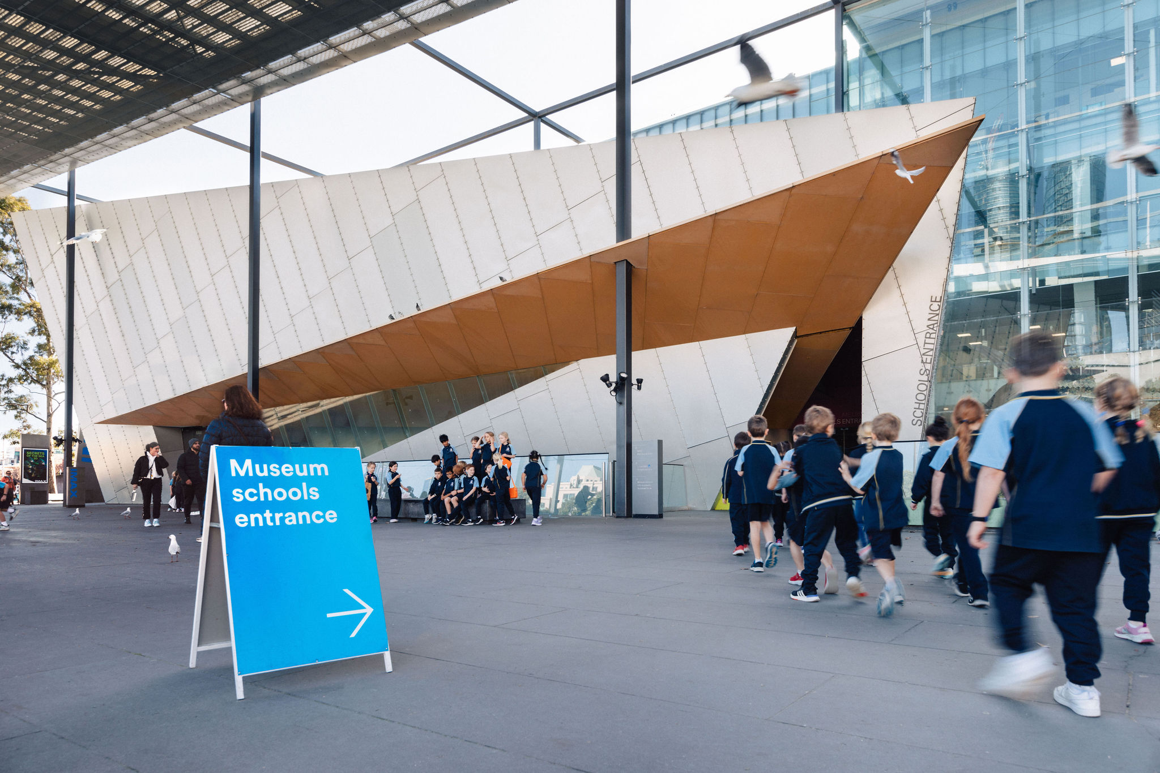

**Arriving at the museum**

I will move with my class across a concrete area to get to the door into the museum. My teacher will go inside to get the program for the day. The class may have to wait outside before we go in.

My bag will be put on a trolley so that I don’t have to carry it all day. A museum staff person will look after it and I will get my bag back later.

I will stand in line before we enter the museum so the teacher can make sure we are safe.

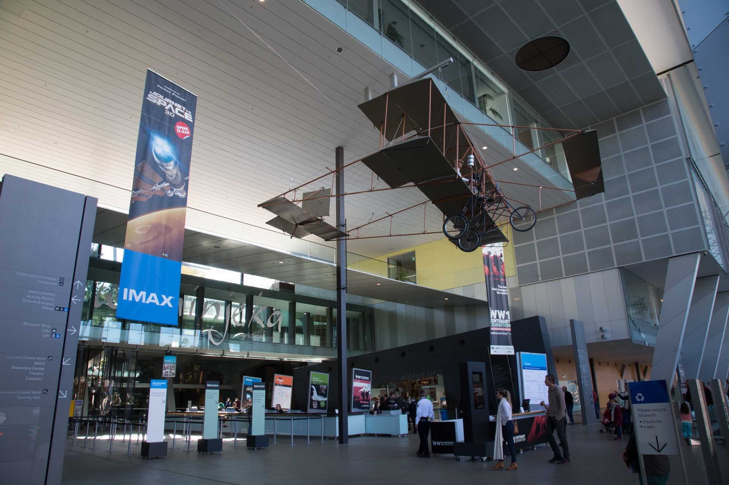

**Going into the museum**

I will go through big glass doors and see a pretend shark, seals, penguins and little fish in the window.

The next bit is a big space with a very high ceiling. There will be an aeroplane hanging from the ceiling above me. It is held up by a VERY strong cable and it will never fall.

I will go with my teacher and my class past the ticket desk into the big area in front of the Forest Gallery. We will begin our museum visit together from here.

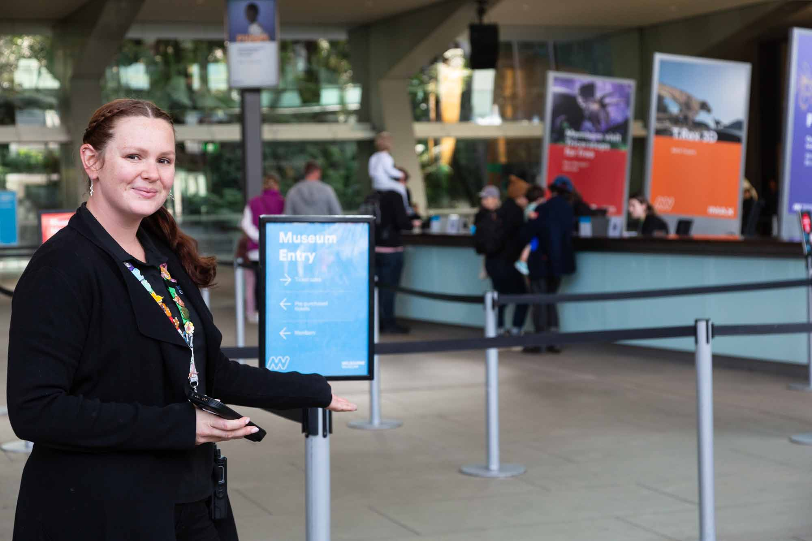

**Staff at the museum**

Many people visit the museum, and many people work there too.

If I get lost, a Visitor Experience Officer can help me find my class. They wear black t-shirts and have coloured straps around their necks.

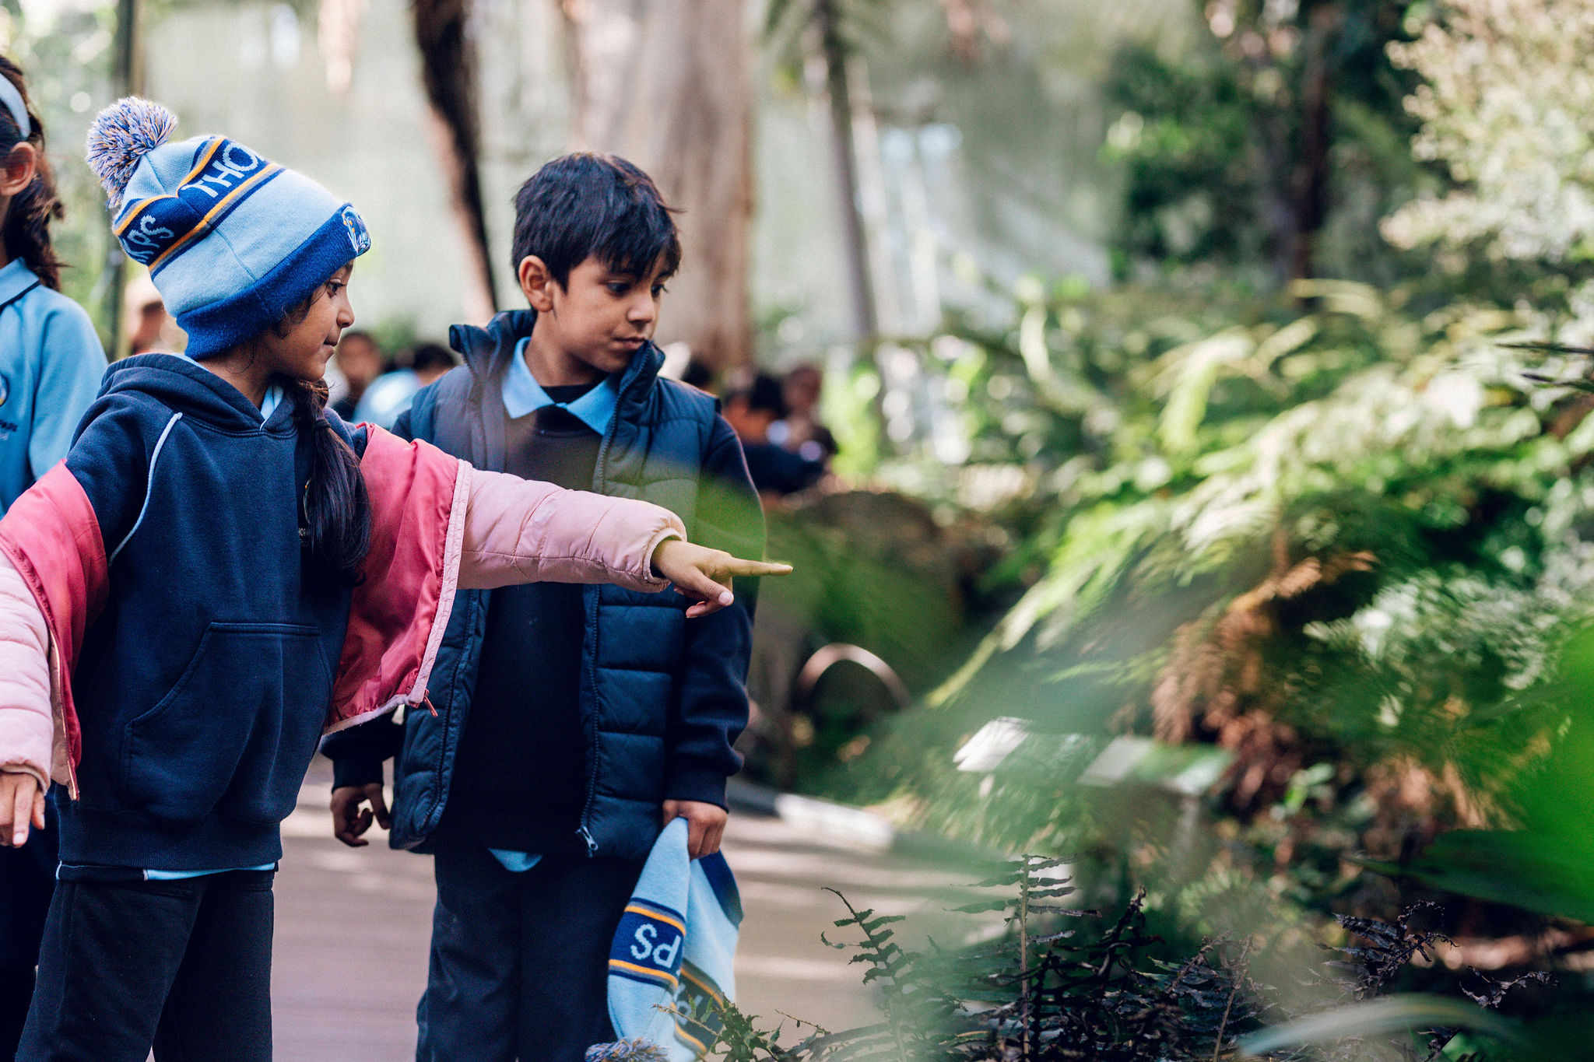

**What will I be doing at the museum?**

My teacher or adult support person knows which exhibitions we are going to visit. I can ask them where we are going and for how long.

Visiting with a school group is different to visiting with my family, as the class needs to stay together and go into exhibitions at the time they are booked.

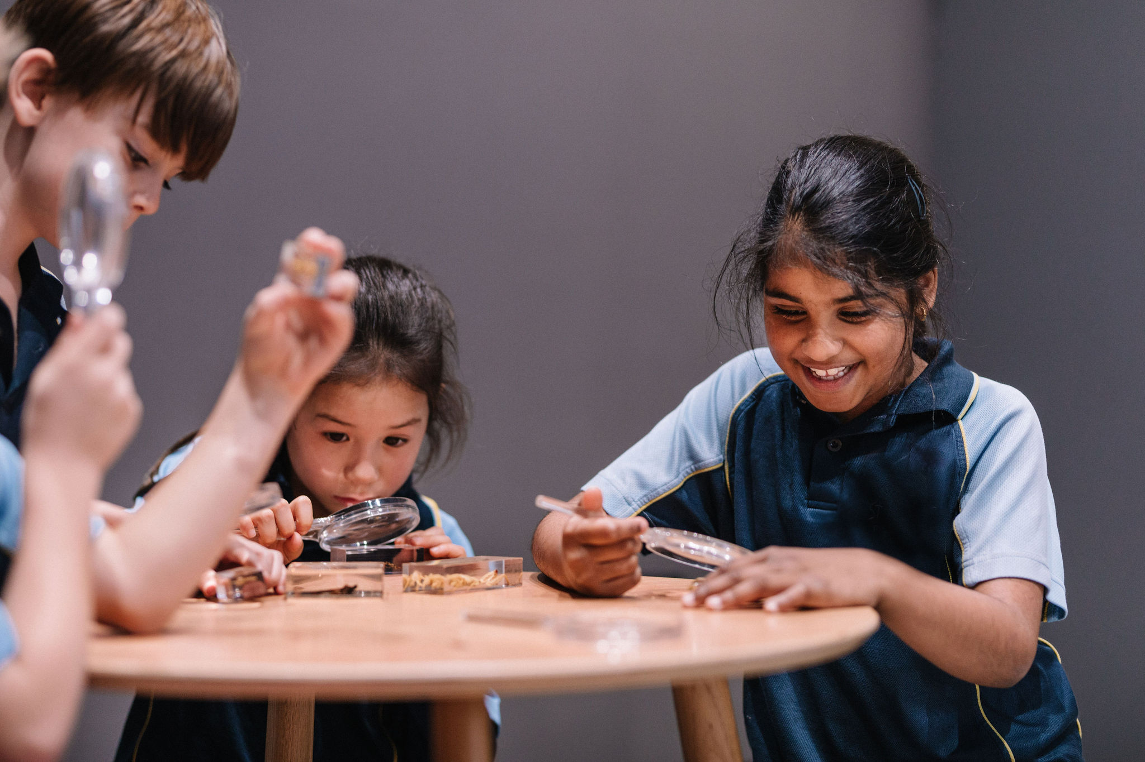

**Special booked programs**

My class might go into special room so a museum teacher can talk to us and teach us something new. If I need to move my body or use a fidget during the session to help me listen, that is ok.

Our class might have the chance to hold, touch or look at special things during our visit. The museum teacher will let us know when we can touch things.

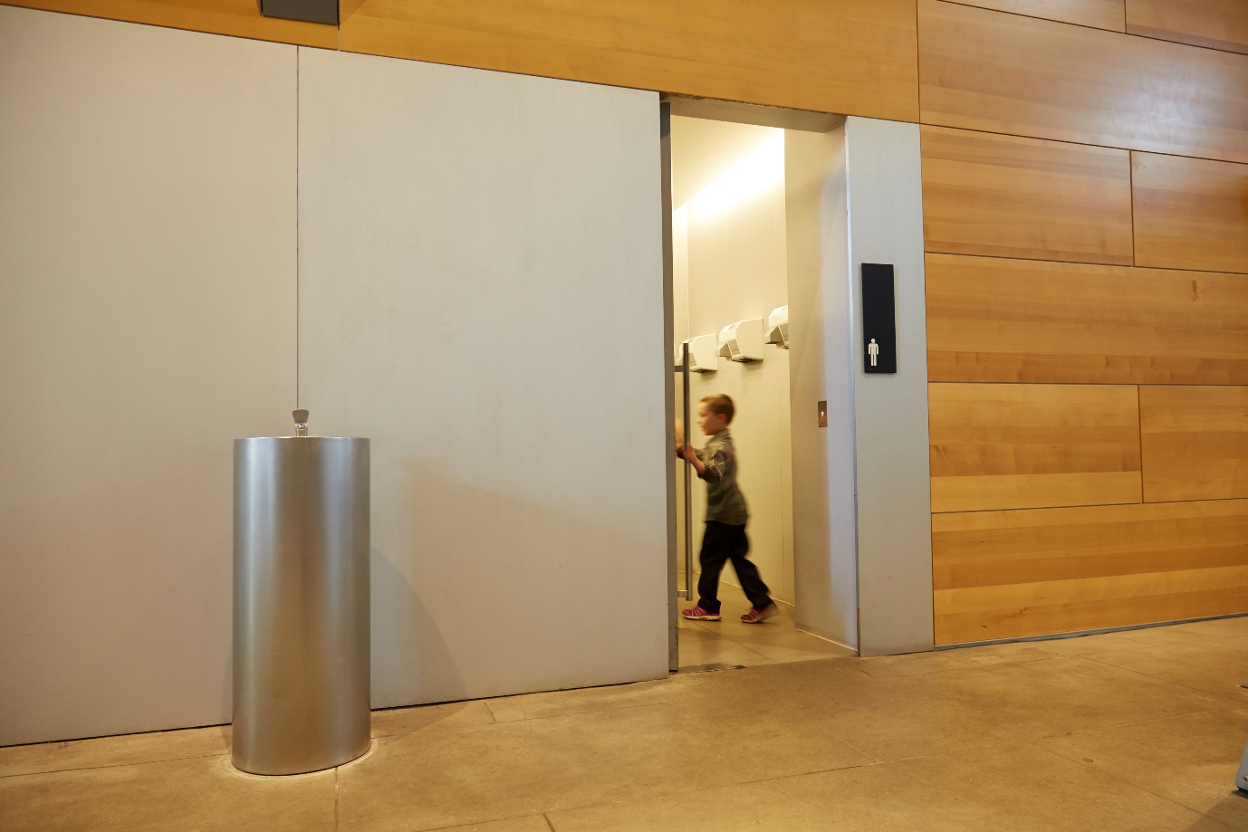

**Toilets at the museum**

I will tell my teacher or adult if I need to go to the toilet and they will take me to a bathroom.

There might be other people in the bathroom too.

The hand dryers in the bathrooms can be very noisy, and I may want to cover my ears.

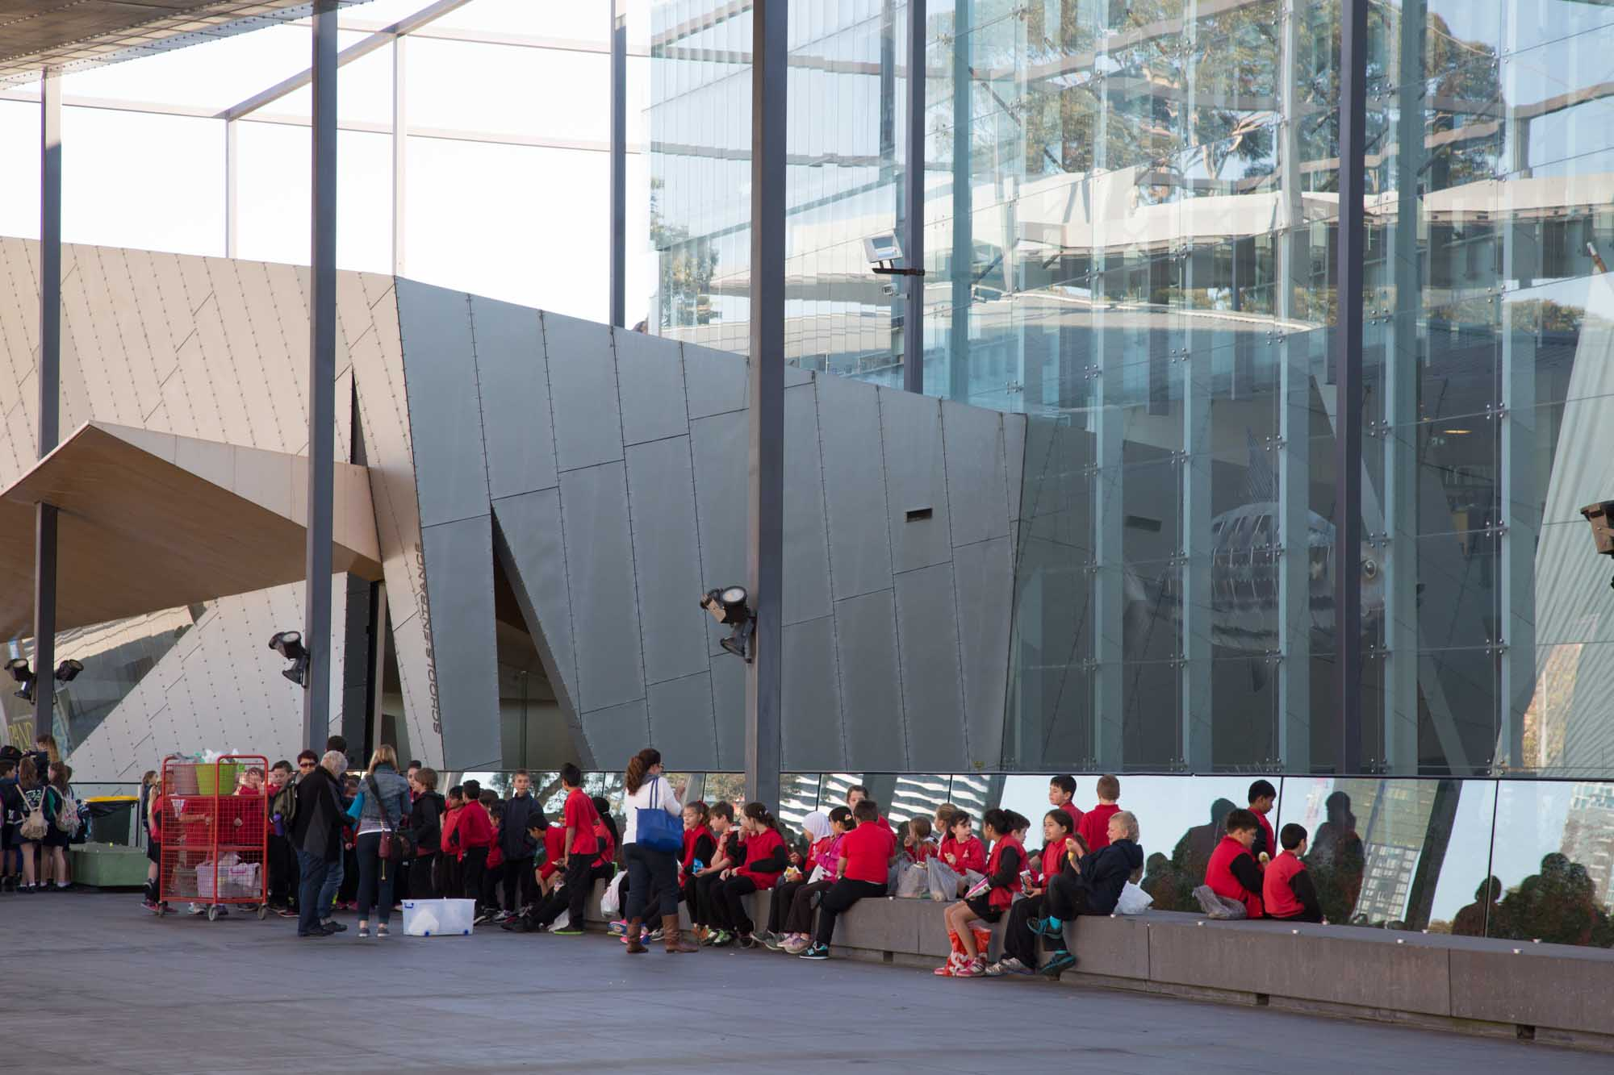

**Food and eating at the museum**

When it is time to eat, I will go with my class to eat outside. We might need to get our bags with our lunch from the trolley.

If it is raining the class might sit on the floor of the museum to eat.

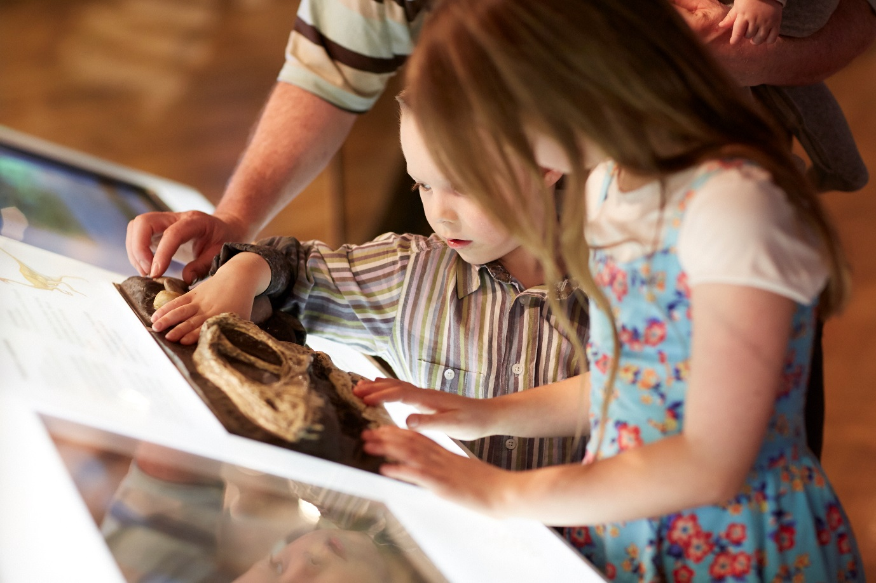

**What can I touch?**

At the museum there will be lots of interesting things. I am allowed to touch some of these things.

There are some things at the museum that no one is allowed to touch. This is to make sure that these special objects are protected forever and never break.

If I am not sure whether I can touch something I will ask my safe adult.

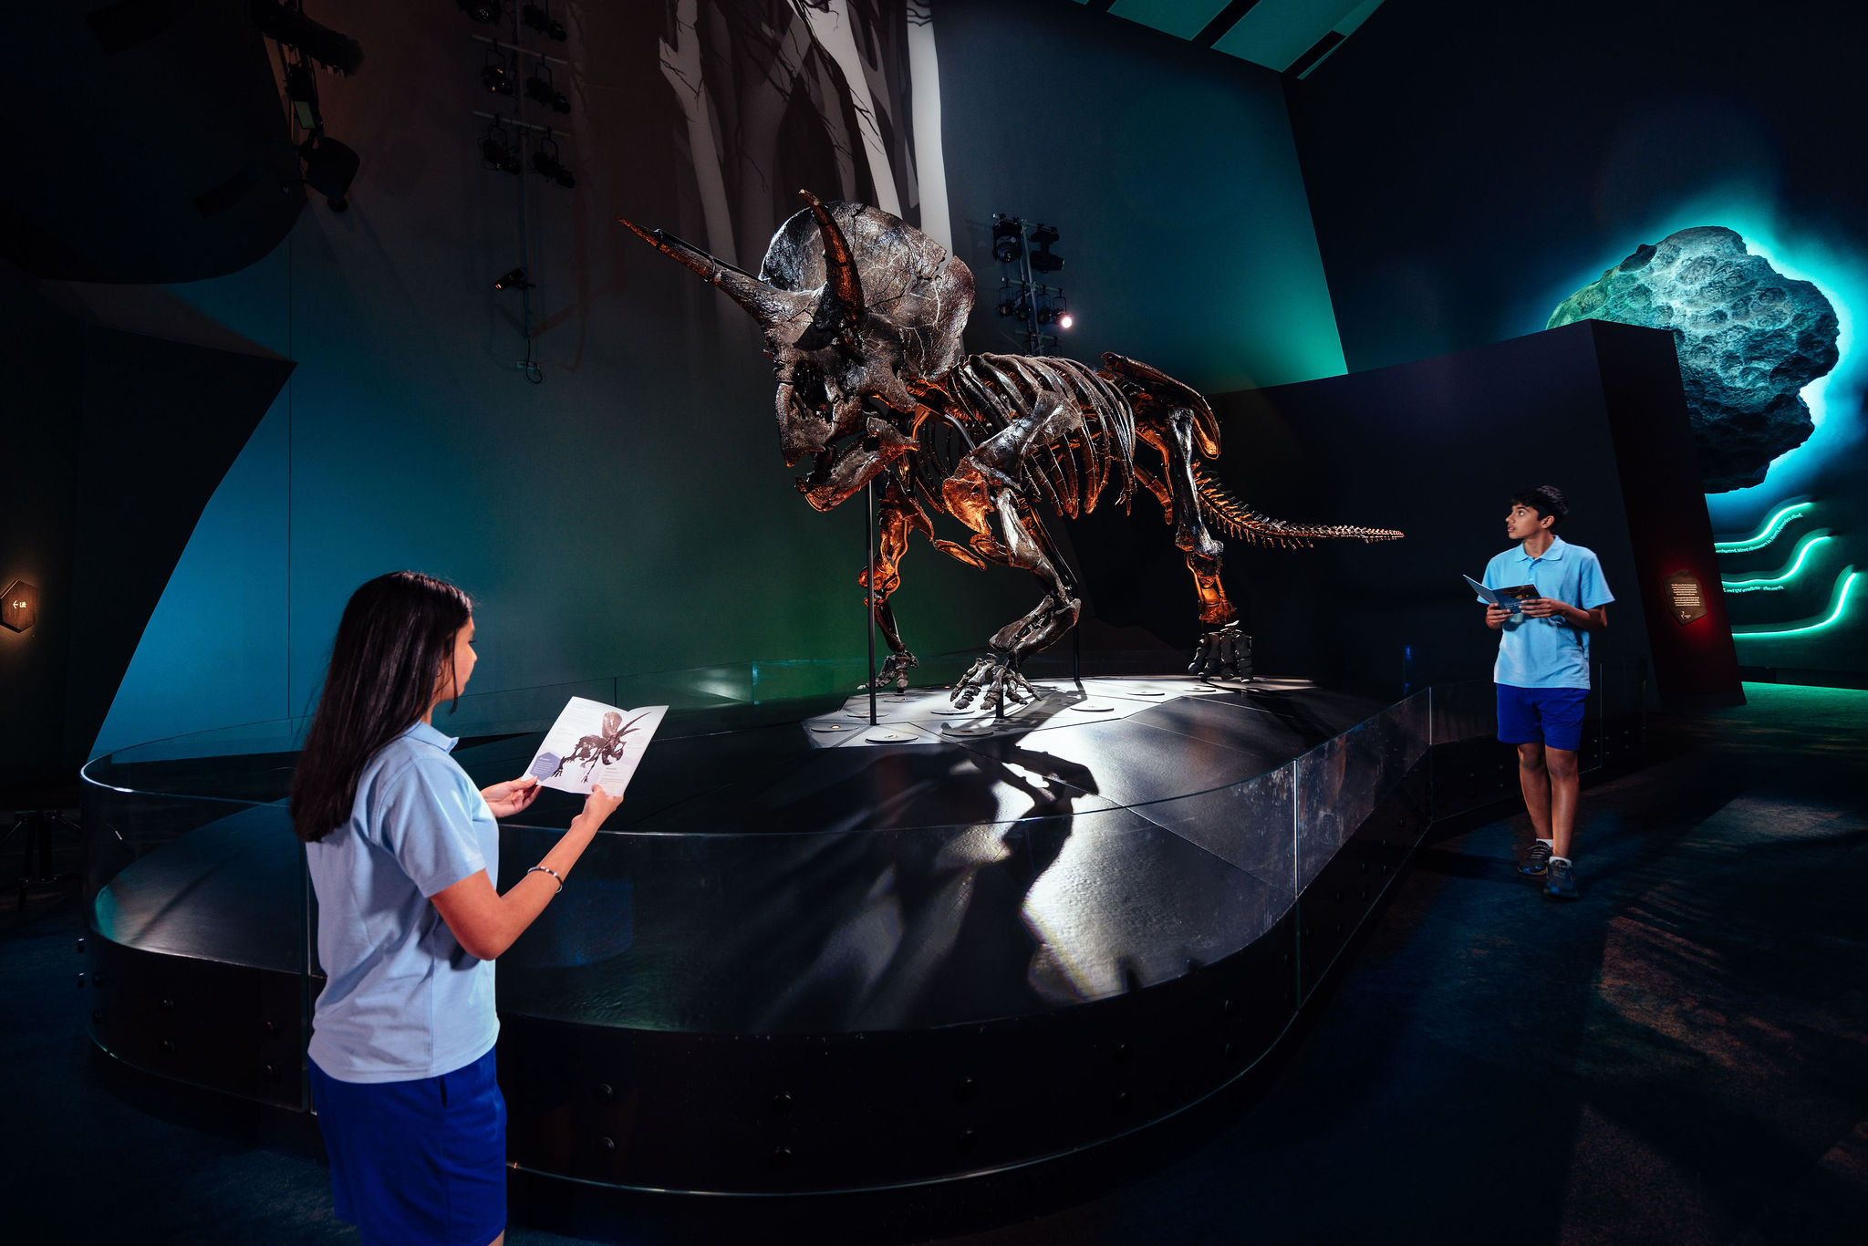

**Big spaces**

The museum is a special building and inside it looks and feels different to home or school. Some rooms at the museum are big. Some rooms at the museum are small. Some rooms at the museum might be dark or bright. If I don’t like being in a room or feel worried, I can tell my safe adult. They can take me somewhere where I feel more comfortable.

After we have done all the things that our teacher has planned, we will go to collect our bags. Then we'll all go back to school.